Contents

**10.8** **Mean, Variance and Standard deviation** 3

**10.9** **Median** 4

**10.10** **Percentile and Quantiles** 5

**10.11** **IQR (Inter Quartile Range) and MAD (Median Absolute Deviation)** 6

**12.1 Introduction to Probability and Statistics** 8

**Random Variables:** 8

**12.2** **Population and Sample** 12

**12.3** **Gaussian/Normal Distribution and its PDF (Probability Density Function)** 14

**12.6** **Standard normal variate (Z) and standardization** 22

**12.7** **Kernel density estimation** 24

**12.8** **Sampling distribution & Central Limit theorem** 24

**12.9** **Q-Q plot: How to test if a random variable is normally distributed or not?** 28

**12.10** **How distributions are used?** 32

**12.11** **Chebyshev’s inequality** 33

**12.12** **Discrete and Continuous Uniform distributions** 41

**12.13 How to randomly sample data points (Uniform Distribution)** 44

**12.14** **Bernoulli and Binomial Distribution** 46

Binomial Distribution 48

**12.15** **Log Normal Distribution** 51

<https://github.com/tirthajyoti/Stats-Maths-with-Python>

this github has code samples for stats

<https://github.com/krishnaik06/Machine-Learning-in-90-days/tree/master/Section%201-%20Python%20Crash%20Course>

**Reference videos and books for stats:**

For video lectures you can refer to Khan Academy, 3blue1brown eyes and for books you can have a look at "**Introduction to Probability and Statistics for Engineers and Scientists**" by **Sheldon M Ross**.

**Histogram bin and bin edges**

**Refer : below video it is explained**

<https://www.appliedaicourse.com/lecture/11/applied-machine-learning-online-course/2819/cdfcumulative-distribution-function/2/module-2-data-science-exploratory-data-analysis-and-data-visualization>

<https://www.youtube.com/watch?v=4AKrmbM0axc>

**PDF is smooth curve of histogram.**

**Kernel density estimation is used to convert histogram into pdf curve**

https://i.imgur.com/x2obv2M.png  
 https://i.imgur.com/QI076vV.png  
 https://i.imgur.com/S8La8cx.png

# consider you have an array like this

a= [1, 2, 3, 5, 10,11, 12, 13, 14, 15, 21,23, 25, 26, 27, 29, 30,31, 35, 51]

here we have decided to group all these numbers into 5 bins

i.e bins = 5

the minimum number in the array is 1

the maximum number in the array is 51

the width of each bin is calculated as = ((max - min) / bins)

width of each bin = (51-1)/5 = 10

Since we got each bin with as 10, we can choose the bin edges like this

1 ...... 11 ....... 21 ........ 31 ....... 41 ....... 51

|---10---|----10----|----10-----|----10----|----10----|

so we have found out the bin edges now

to find thte counts we calcuate how many number of points fall into each bin

therefore the count of a bin = number of elements of a such that left_bin_egde<=ai 5 [1,2,3,5,10]

ii. number of elements belongs to the 2nd bin 11<=x<21 => 5 [11,12,13,14,15]

iii. number of elements belongs to the 3rd bin 21<=x<31 => 7 [21,23,25,26,27,29,30]

iii. number of elements belongs to the 3rd bin 21<=x<31 => 7 [21,23,25,26,27,29,30]

iv. number of elements belongs to the 4th bin 31<=x<41 => 2 [31,35]

v. number of elements belongs to the 5th bin 41<=x<=51 => 1 [51]

# **10.8 Mean, Variance and Standard deviation**

<https://www.mathsisfun.com/data/standard-deviation.html>

Mean: : *μ*

The mean is the average of the numbers.

It is easy to calculate: add up all the numbers, then divide by how many numbers there are.

Symbol for mean: *μ*

Mean: Sum(data values)/number of values

central value of the data, are majorly impacted by outliers

**Standard Deviation definition**

The Standard Deviation is a measure of how spread out numbers are.

Standard deviation: The width of the spread of the values on an axis

Its symbol is σ (the greek letter sigma)

The formula is easy: it is the square root of the Variance.

**Variance definition :** σ*2*

The Variance is defined as:

The average of the squared differences from the Mean. 🡪 from mathsisfun

Variance: Summation squares of distance of values from mean whole divided by N

Standard deviation = sqrt(variance)

Formulas for standard deviation :

|  |  |  |
| --- | --- | --- |
| The "**Population** Standard Deviation": |  | square root of [ (1/N) times Sigma i=1 to N of (xi - mu)^2 ] |

|  |  |  |
| --- | --- | --- |
| The "**Sample** Standard Deviation**":** |  | square root of [ (1/(N-1)) times Sigma i=1 to N of (xi - xbar)^2 ] |

Looks complicated, but the important change is to divide by N-1 (instead of N) when calculating a Sample Variance.

These are corrupted if an outlier exists; use median

# **10.9 Median**

The Median is the "middle" of a sorted list of numbers.

Sort the list in an increasing order and pick the middle value;

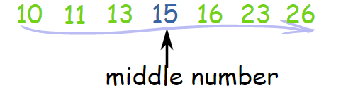

If Two Numbers in the Middle

BUT, with an even amount of numbers things are slightly different.

In that case we find the middle pair of numbers, and then find the value that is half way between them. This is easily done by adding them together and dividing by two.

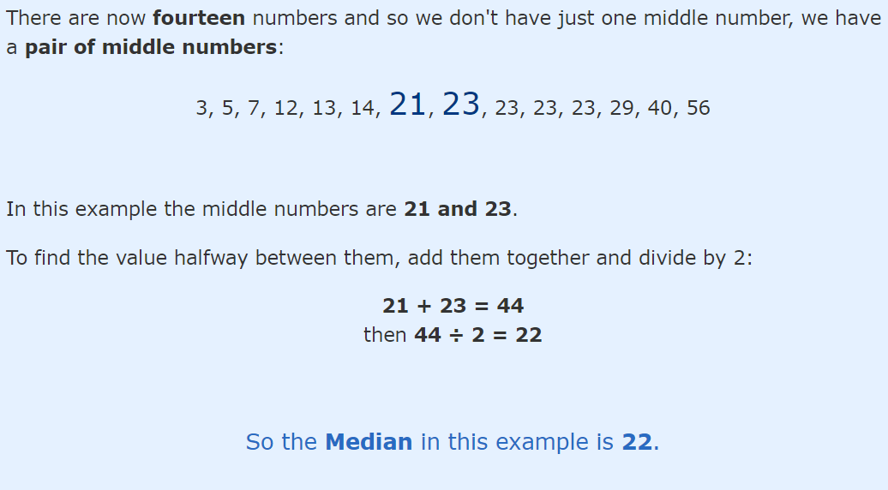

Median does not get corrupted due to presence of outliers; better statistic for central tendency;

# **10.10 Percentile and Quantiles**

Percentile: Number of values lesser than the percentile percentage of values;

50th percentile: the value at which 50% of values are less than this value

Quantiles: 25th percentile, 50th percentile, 75th percentile

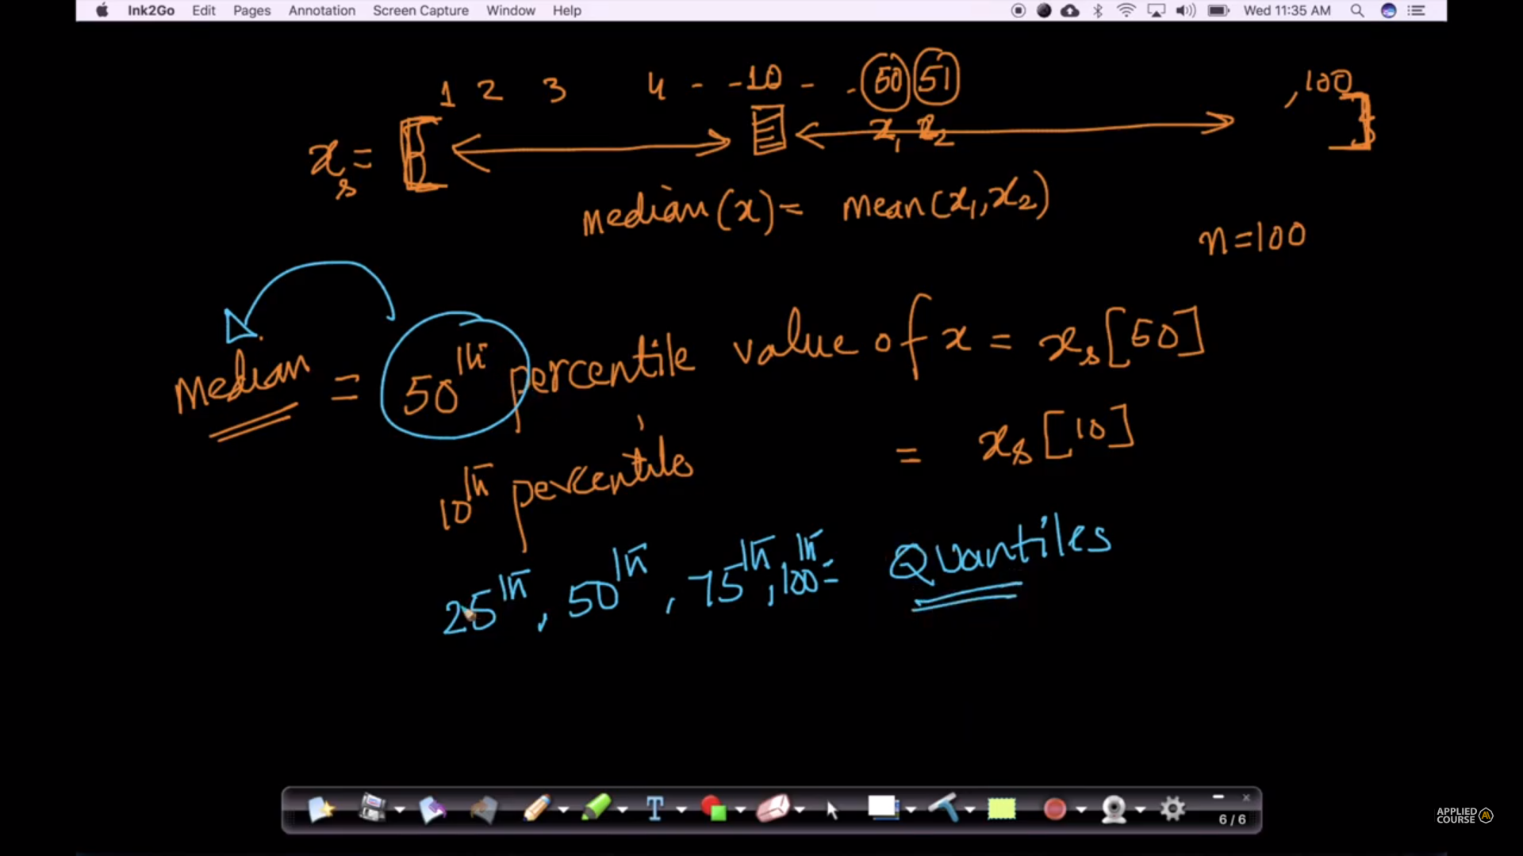

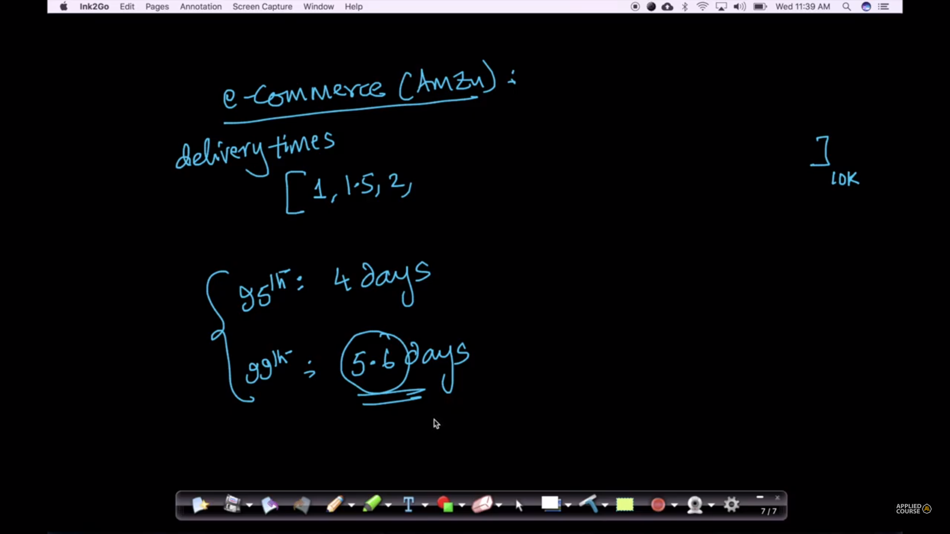

# **10.11 IQR (Inter Quartile Range) and MAD (Median Absolute Deviation)**

<https://soundcloud.com/applied-ai-course/mad-usage>

IQR: 75th percentile value – 25th percentile value



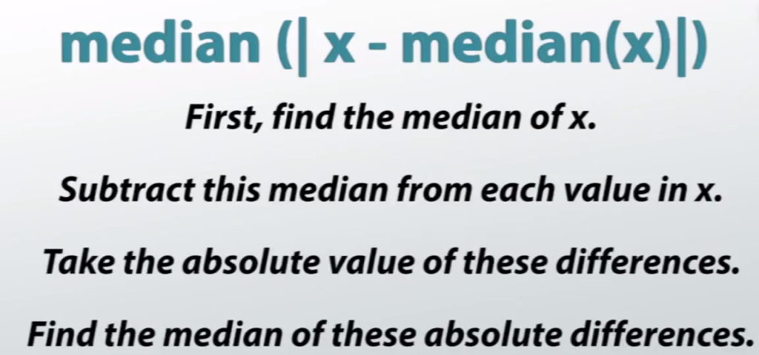

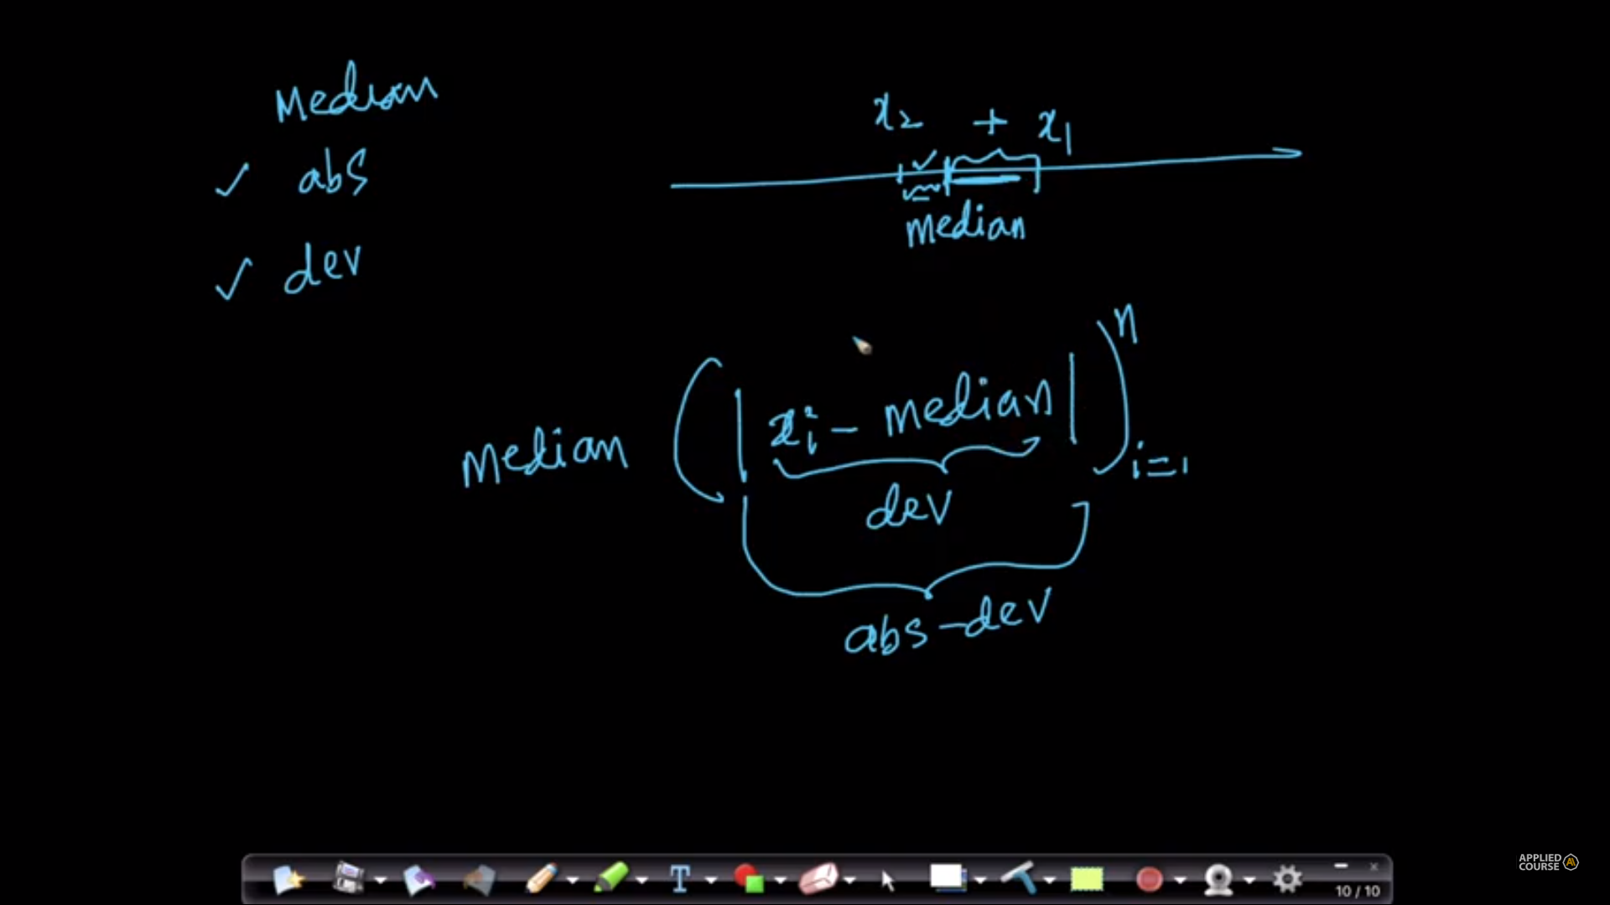

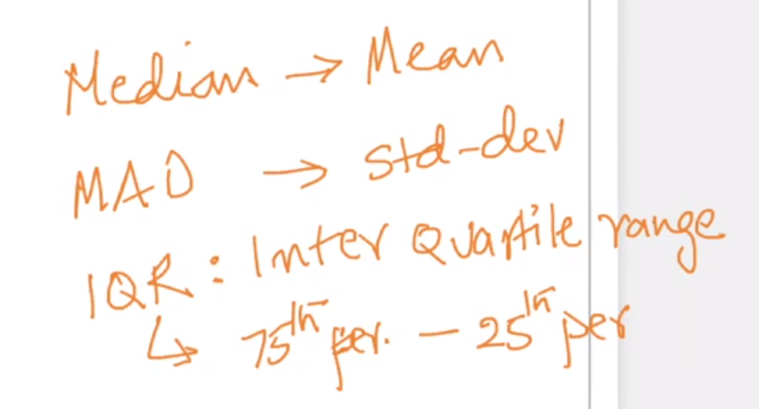

**From applied ai comment sections :**

The **median absolute deviation**is a measure of spread that represents expected absolute-error loss, and is **more robust** to outliers. In this case, outliers do not manifest in large increases in the measure of spread. The **standard deviation** is a measure of spread that represents expected squared-error loss, and is **more sensitive**to outliers. In this case, the outliers will manifest in large increases in the measure of spread.

[**Standard Error Loss vs. Absolute Loss**](https://math.stackexchange.com/questions/1592151/standard-error-loss-vs-absolute-loss)

absolute error (Y,X ) = | Y-X |, while squared error(Y,X) = (Y -X) (Y-X)

When plotting the two, you hopefully had this plot down:

[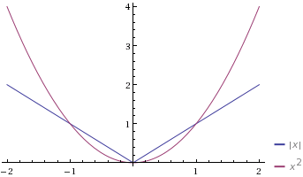](https://i.stack.imgur.com/whp7j.gif)

The purple plot is squared error and the blue plot is absolute error. From these plots, you see that squared error is smaller than absolute error when we're close to 0 (i.e. your prediction is close to your actual value) and squared error is much larger than absolute error when you're far away from 0. They agree when the error is equal to 1.

Even though the plots meet up at 0 when x = 0 you shouldn't think of the two types of errors as being the same when we're that close.

Whenever the chances of having the outliers in the given data is high, in such cases, the mean and the standard deviation easily get affected due to the presence of outliers/noise. In such cases, it is recommended to go with Median and MAD instead of Mean and Standard Deviation.  
Mostly during the data preprocessing phase itself, we remove the outliers from the data. But in some cases, the outliers also add much value to the models and are required to be present in the train data for the training phase. In such cases, as you are not supposed to remove the outliers, you have to go for Median and MAD instead of going for Mean and SD.

# **12.1 Introduction to Probability and Statistics**

# **Random Variables:**

Datasets with well separable classes do not require ML methods to be applied, but classes that are well mixed cannot be separated easily;

The data points that lie in the mixed region cannot be clearly stated to belong to a certain class; instead we can have probability values of the data point belonging to each class;

Histograms, PDF, CDF, mean, variance, etc come under probability and statistics

Random Variable: can take multiple values in a random manner

Ex: Dice with 6 sides: Roll a fair dice: the 6 outcomes of the dice are equally likely

r.v. X = {1, 2, 3, 4, 5, 6}

Coin toss: r.v. X = {H, T}

Dice roll: Probability of X = 1 is 1/6

Probability of X = even is {2,3,4}/{1,2,3,4,5,6} = 3/6 = ½

= prob(x=2) + prob(x=4) + prob(x=6)

Height of a randomly picked student: Y = [120 to 190 cm]

**Discrete random variable: a value from a set of values**

A variable which takes countable number of distinct values. OR the variables whose values are obtained by counting is called Discrete Random Variable. For e.g, number of students present in class

**Continuous random variable: a value from a range of values**

A variable which having the values between the range/interval and take infinite number of possible ways is called Continuous random variable . OR the variables whose values are obtained by measuring is called Continuous random variable. For e.g, A average height of 100 peoples, measurement of rainfall

**Outlier**: Y: Height of students:

Let: Y = {122.2, 146.4, 132.5, …, 12.26, 156.23, 92.6}

Outliers: 92.6 and 12.26: may have occurred due to input error or data collection error or may be a genuine value but does not indicate general trend of the population

Refer :

<http://www.henry.k12.ga.us/ugh/apstat/chapternotes/7supplement.html>

A **variable** is a quantity whose value changes.

A **discrete variable** is a variable whose value is obtained by counting.

*Examples*:     number of students present

                                    number of red marbles in a jar

                                    number of heads when flipping three coins

                                    students’ grade level

A **continuous variable**is a variable whose value is obtained by measuring.

*Examples*:     height of students in class

                        weight of students in class

                        time it takes to get to school

                        distance traveled between classes

**A random variable is a variable whose value is a numerical outcome of a random phenomenon.**

**A Random Variable is a set of possible values from a random experiment.**

▪         A random variable is denoted with a capital letter

▪         The probability distribution of a random variable *X* tells what the possible values of *X* are and how probabilities are assigned to those values

▪         A random variable can be discrete or continuous

A **discrete random variable** *X* has a countable number of possible values.

*Example*: Let *X* represent the dice roll.

Then the probability distribution of *X* is as follows:

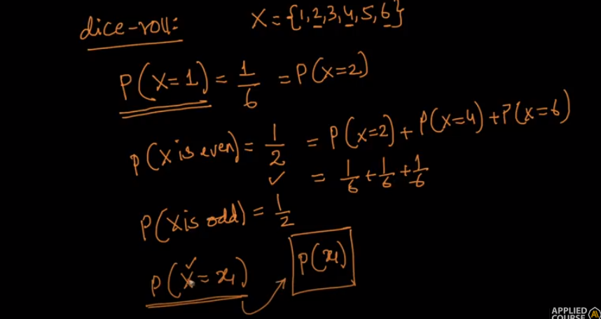

A **continuous random variable** *X* takes all values in a given interval of numbers.

If we consider height of a randomly picked student:

Height may range from 120cm to 190cm

So y may be any value in b/w 120 and 190.

Y=162.45 or Y=132.45

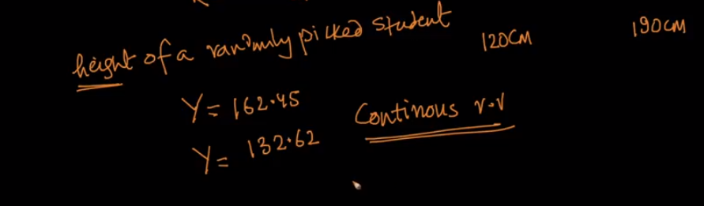

Below explanation image is taken from applied ai comment section:

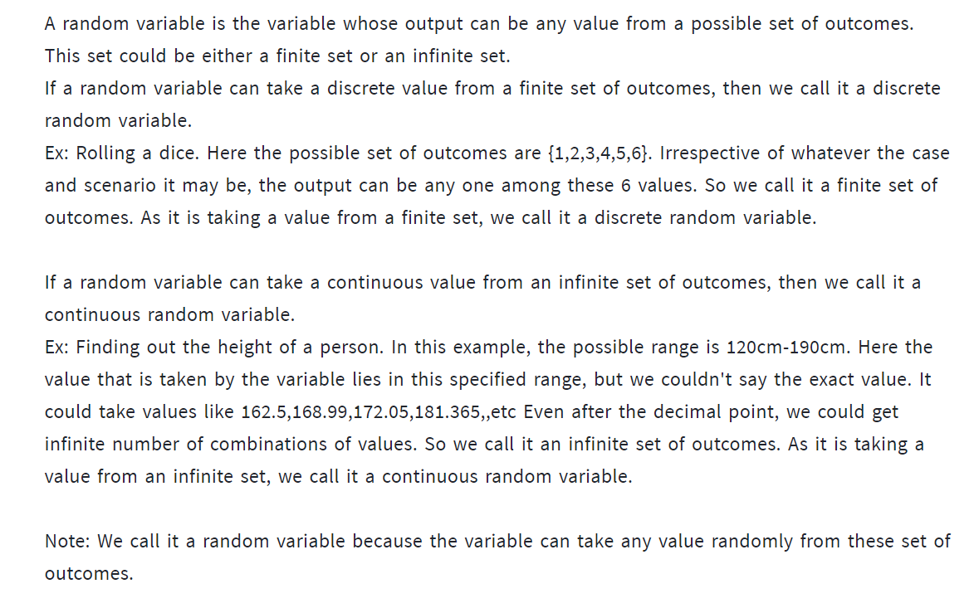

**OUTLIER:**

In statistics, an outlier is a data point that differs significantly from other observations. An outlier may be due to variability in the measurement or it may indicate experimental error; the latter are sometimes excluded from the data set. An outlier can cause serious problems in statistical analyses. [Wikipedia](https://en.wikipedia.org/wiki/Outlier)

Mean will be corrupted by outlier

Variance also get impacted by outlier so we use median and median absolute deviation

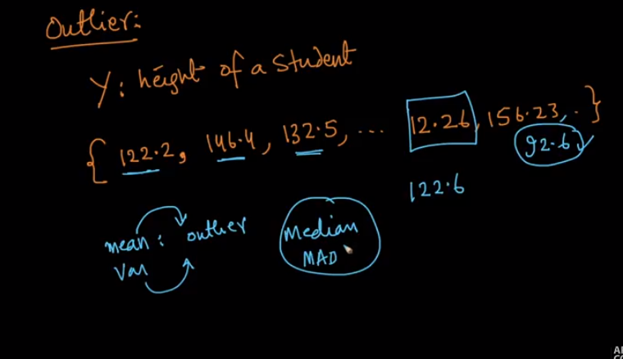

# **12.2 Population and Sample**

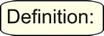

A population data set contains all members of a specified group (the entire list of possible data values). [Utilizes the count n in formulas.]  
Example: The population may be "ALL people living in the US."

A sample data set contains a part, or a subset, of a population. The size of a sample is always less than the size of the population from which it is taken. [Utilizes the count n - 1 in formulas.]  
Example: The sample may be "SOME people living in the US."

**Population vs Sample**

The main difference between a population and sample has to do with how observations are assigned to the data set.

* A **population** includes all of the [elements](https://stattrek.com/Help/Glossary.aspx?Target=element) from a set of data.
* A **sample** consists one or more observations drawn from the population.

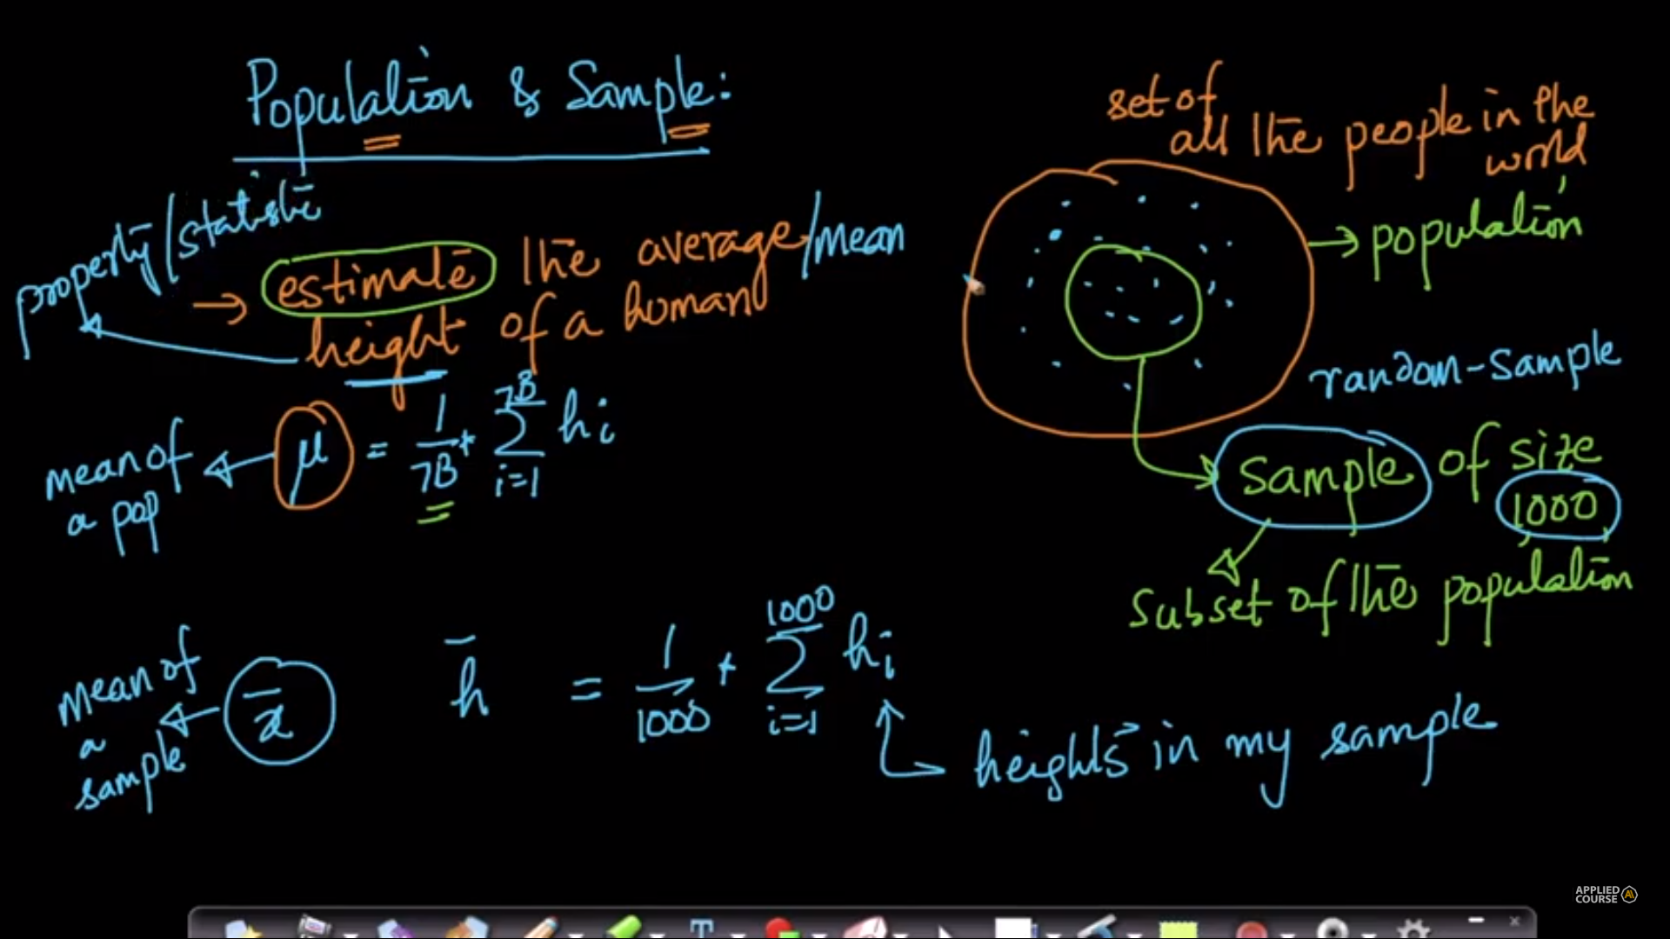

As sample size increases sample mean value almost equal to population mean

Collecting all the population height data is not possible; we will take a random sample (subset of the population)

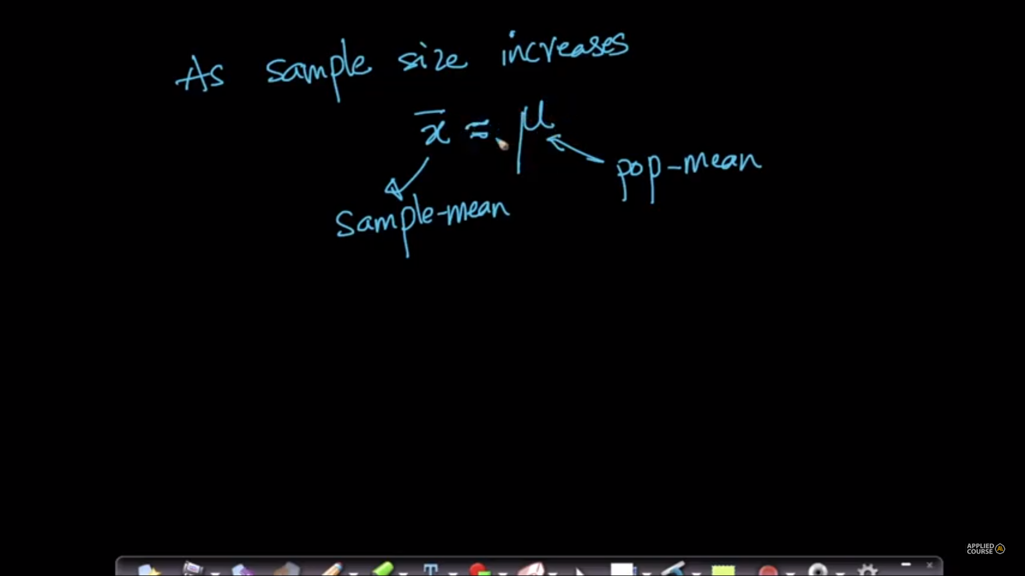

To understand mean, standard deviation and variance refer below link: very good link with dog height exmple

<https://www.mathsisfun.com/data/standard-deviation.html>

# **12.3 Gaussian/Normal Distribution and its PDF (Probability Density Function)**

Good material link :

<https://towardsdatascience.com/pdf-is-not-a-probability-5a4b8a5d9531>

<https://towardsdatascience.com/fundamental-statistics-7770376593b>

[becominghuman.ai/an-introduction-to-probability-and-statistics-for-data-science-8cbcdd3f266d](http://becominghuman.ai/an-introduction-to-probability-and-statistics-for-data-science-8cbcdd3f266d)

In a more precise sense, the PDF is used to specify the probability of the [random variable](https://en.wikipedia.org/wiki/Random_variable) falling within a particular range of values, as opposed to taking on any one value. This probability is given by the [integral](https://en.wikipedia.org/wiki/Integral) of this variable's PDF over that range—that is, it is given by the area under the density function but above the horizontal axis and between the lowest and greatest values of the range.

PDF is the probability function which maps the input variable to its probability value over a range. Now the total probability should be 1, hence the area under the curve for PDF is 1.   
  
CDF is the probability of value less than equal to the input. That means, it sums up all the probabilities of the values upto that given value.

the probability for a continuous random variable is called the probability distribution function..

PDF at a point is not possible because there is no area of a line PDF at a particular interval is defined ,for eg PDF(2)

Probability density function p(x)=y=

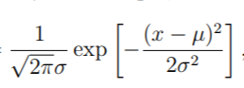

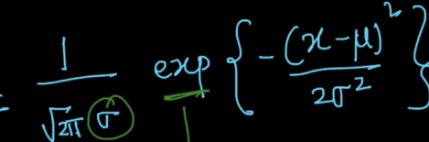

Let’s say x is a continuous variable and it’s the distribution (PDF) like a bell-shaped curve, then we can say x has a distribution which is Gaussian distribution. Now, you might be wondering why we should study Gaussian distribution because a lot of things in nature follow Gaussian distribution like height, the weight of people, etc.

Now, that question also comes to mind why we should learn such distribution?

We learn distributions to understand the underlying statistics or trends of the population

Let’s suppose you know that some variable follows Gaussian distribution then we can say a lot about the properties of that variable without putting much efforts (will see later).

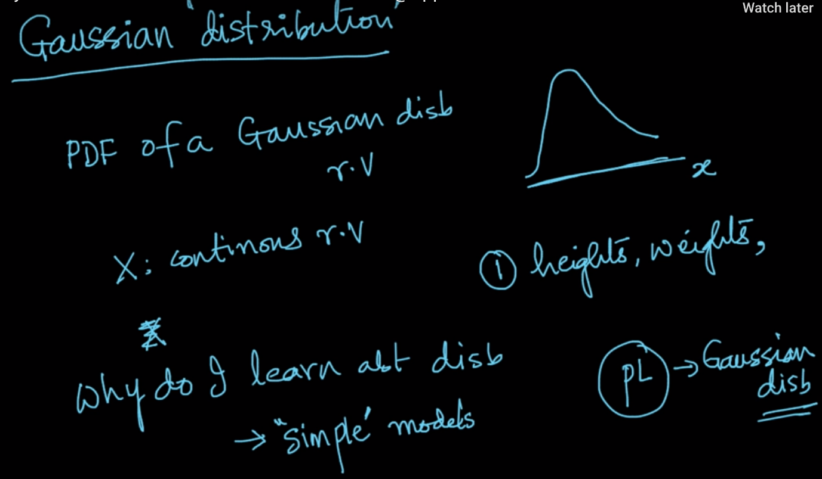

Gaussian distribution is also known as the normal distribution. Here mean and variance are called the parameters of the distribution, so, if we have these two values then we could say how it’s PDF will look like.

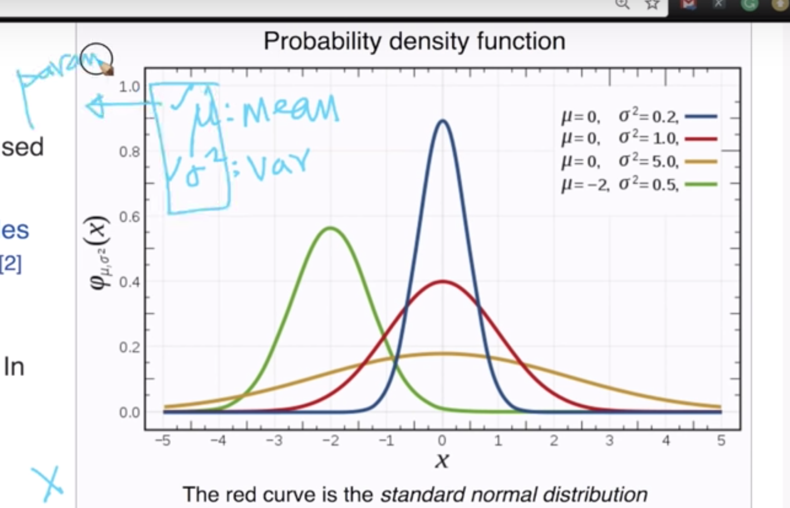

So, If you know that the continuous variable follows the Gaussian distribution then we can draw the PDF of that variable by just knowing it’s mean & variance. Or assume we have the gaussian distribution of a variable then we could say the highest peak point is it’s mean and it’s spread is it’s variance.

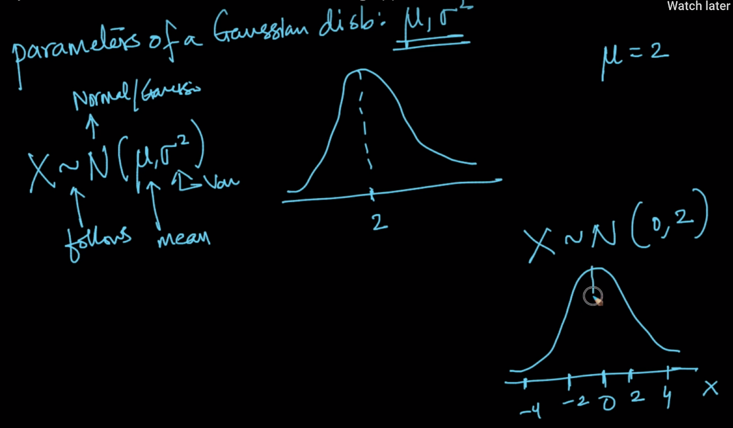

Let’s look into the mathematical details of this as well. So, Let’s suppose we have the parameters (mean & variance) then we could write the PDF of x as below:

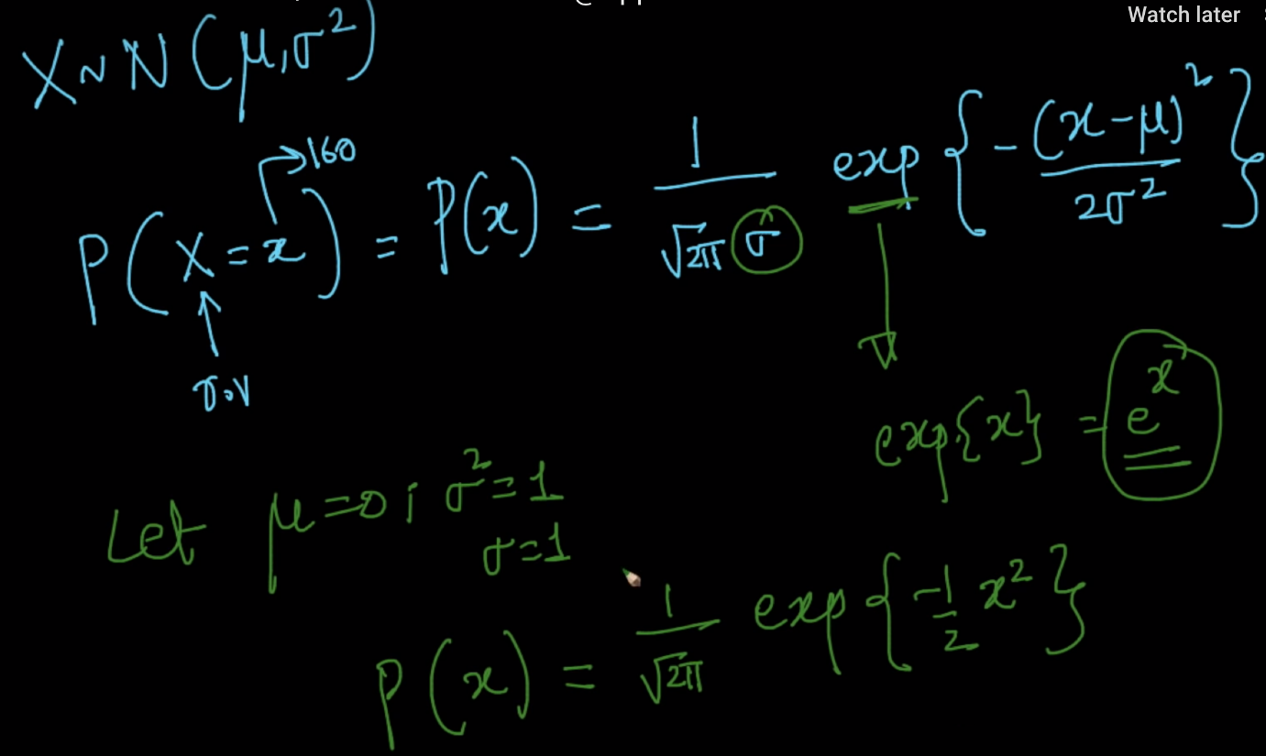

Now, let’s see if our mean is 0 and our variance is 1 then we could see/plot the above equation like this:

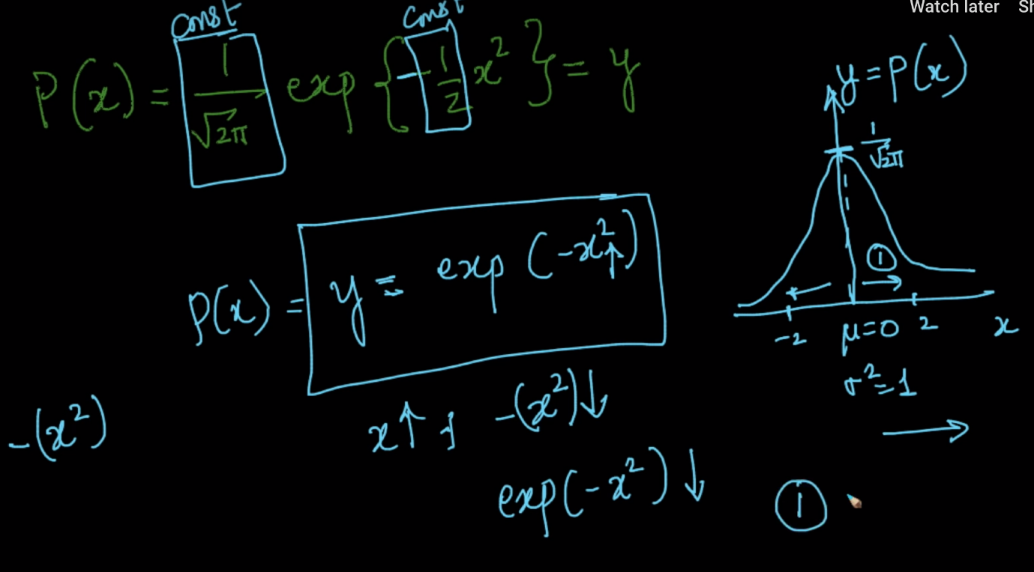

we get some conclusion of Gaussian distribution is as below:

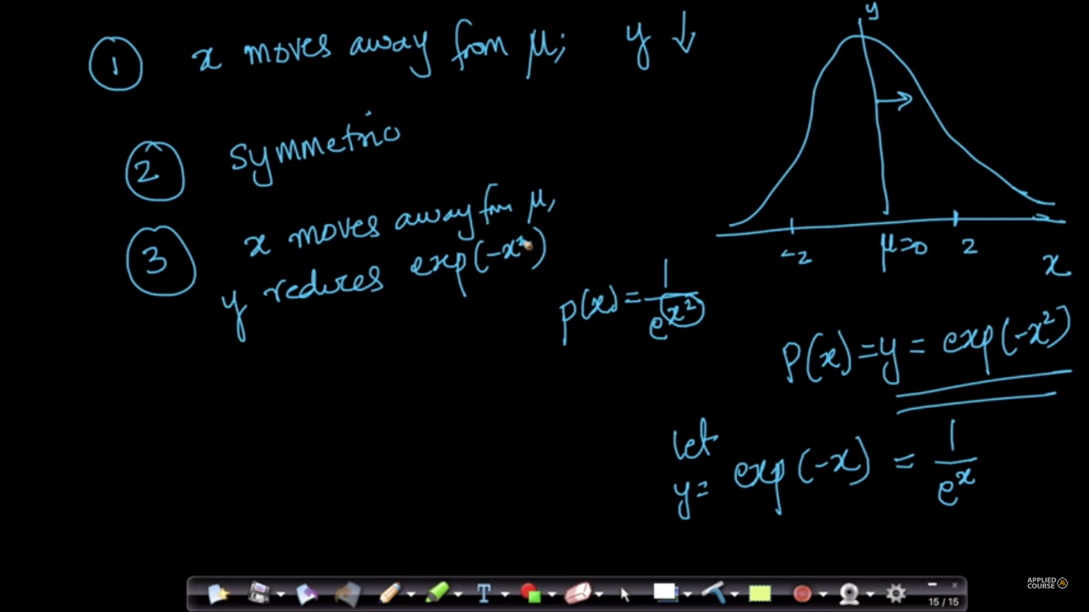

The value of y reduces the exponential of quadratic (drastically) like shown in the below example.

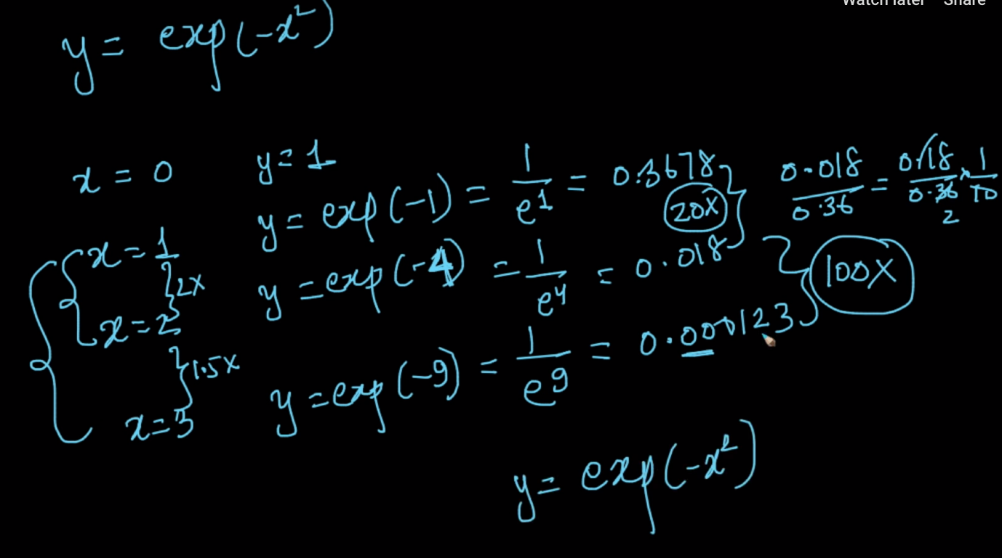

**The 68–95–99.7 rule**: It states that nearly 68% of the points lies between first standard deviation both sides, the 95% of the points like between 2 standard deviations both sides and 99.7% of the points lie between 3 (as shown in the figure).

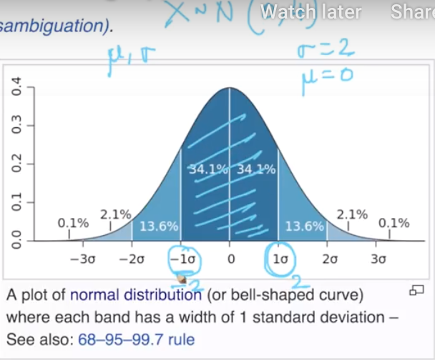

**Imp points :**

Bell shaped curve: Gaussian distribution Probability density function curve;

X: continuous random variable;

Real world variables mostly follow Gaussian distribution; Height, Weight, Length

We learn distributions to understand the underlying statistics or trends of the population

If X behaves as a Gaussian distribution: Given mean and standard variance:

We can estimate the values of the population; by plotting the PDF

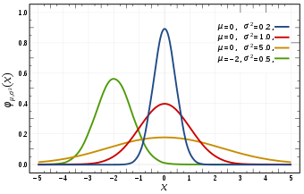

The red curve is standard normal distribution

Parameters of Gaussian distribution: Mean and variance:

X ~ N (0,1) (mean 0 and variance 1)

PDF(X = x) =



As x moves from mean, the pdf reduces;

The PDF of a Normal distribution is symmetric;

***Probability distribution*** is a function that describes all the possible likelihoods and values that can be taken by a random variable within a given range.

For a **continuous random** variable, the **probability** distribution is described by the **probability** **density function**. And for a **discrete random variable**, it’s a **probability** **mass functio**n that defines the **probability** distribution.

**Probability** distributions are categorized into different classifications like binomial distribution, chi-square distribution, normal distribution, Poisson distribution etc. Different **probability** distributions represent different data generation process and cater to different purposes.

# **12.6 Standard normal variate (Z) and standardization**

Refer : <https://365datascience.com/standardization/>

Python code to identify outlier using z score and IQR link is below:

<https://github.com/raffeemdai/machine-learning/tree/master/Finding-an-Outlier-krishnaik_Z-%20score%20and%20IQR>

Z ~ N(0,1), mean = 0 and variance = 1

Let X ~ N(µ,σ2); this can be converted to Z by:

Mean centering and scaling (X – mean) / std dev; To help understand the disb.

Z is called standard normal variate

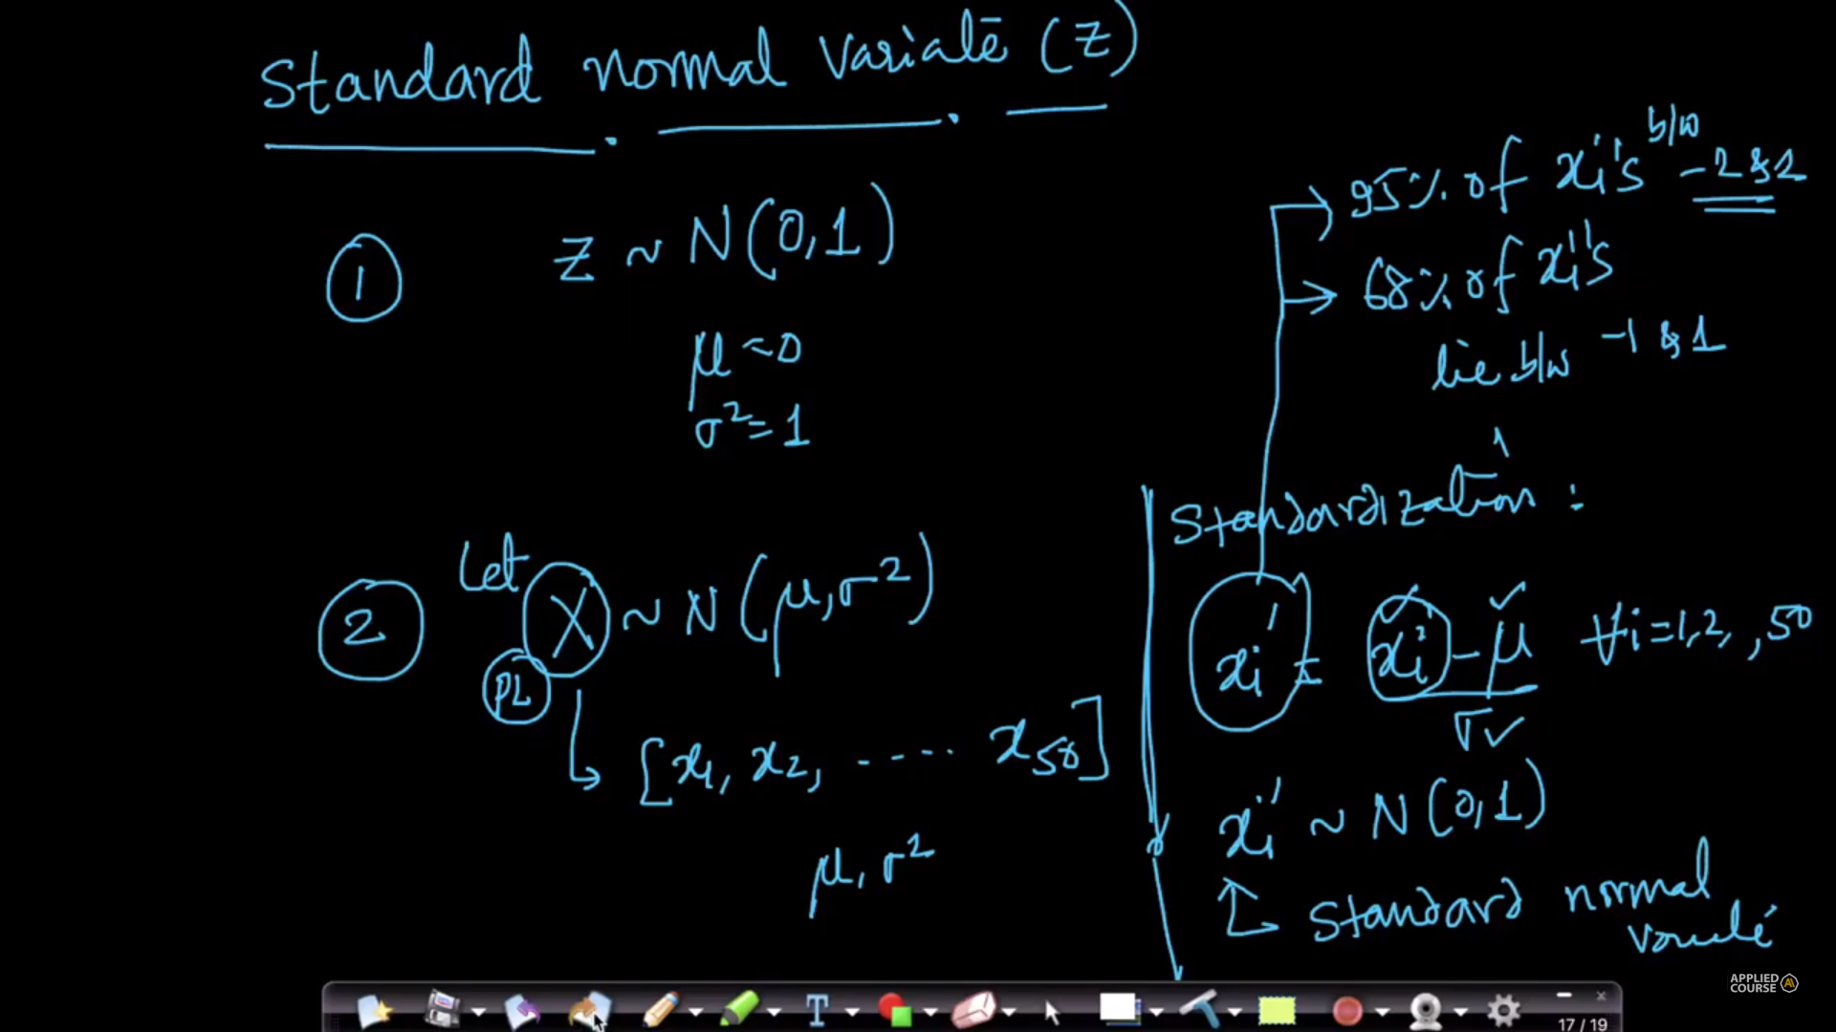

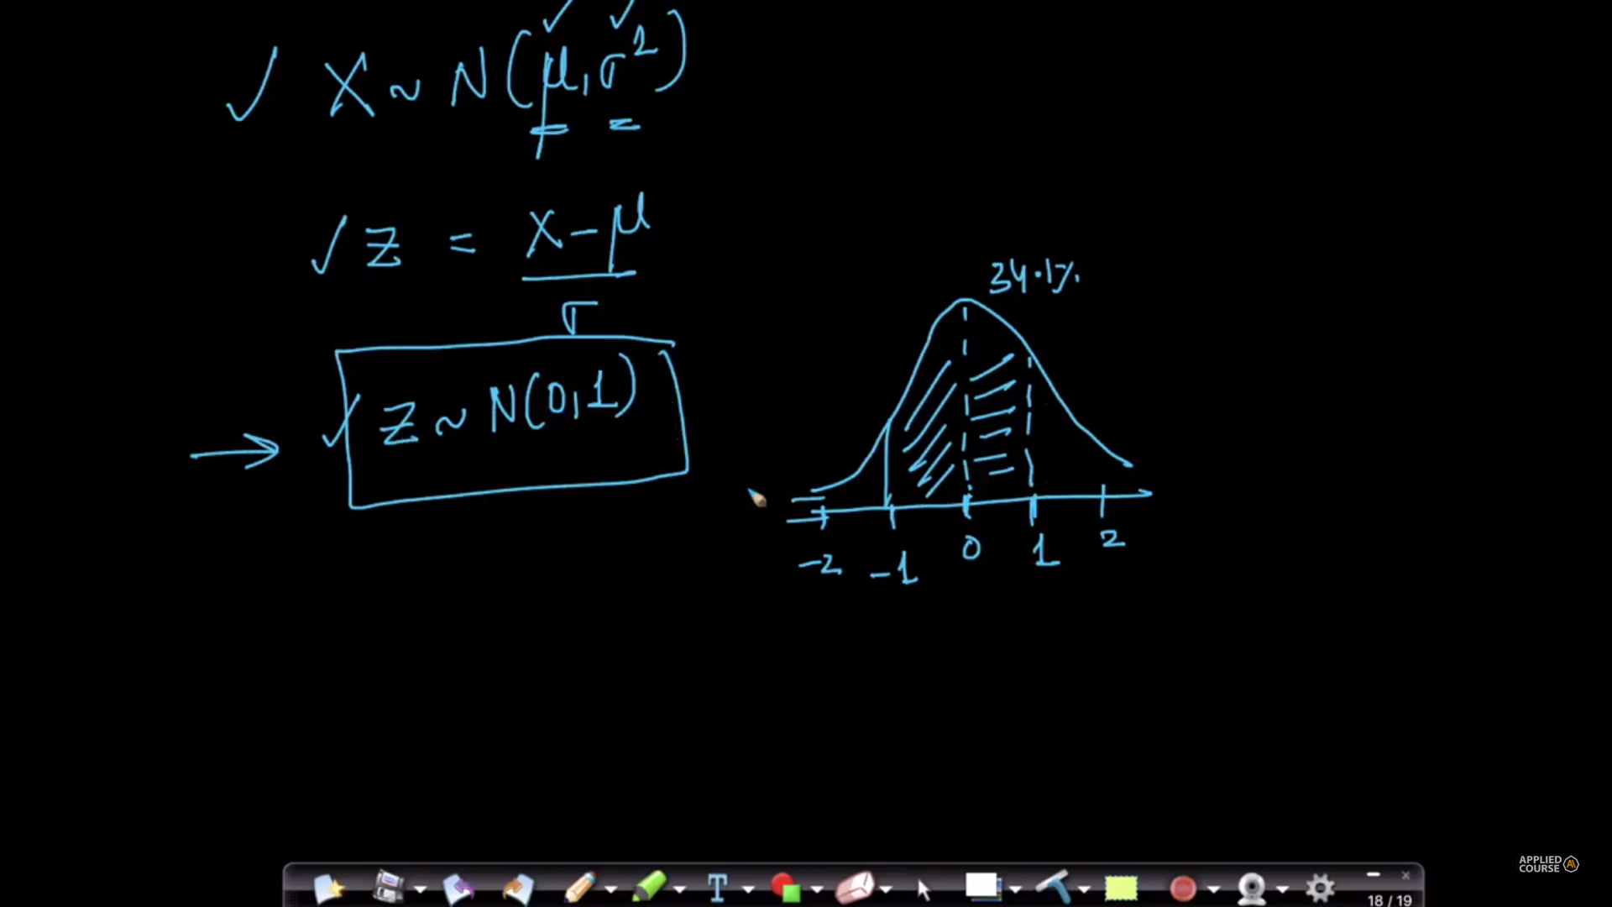

A normal distribution with a mean of zero, and a standard deviation of 1, is known as a standard normal distribution. This is the normal distribution that is used for statistical tables.

PDF is also written as when μ =0 and σ2 =1

|  |  |  |  |
| --- | --- | --- | --- |
| 1 | e |  | -(x-μ)2 / (2σ2) |
| σ√(2π) |  |  |

|  |  |  |  |
| --- | --- | --- | --- |
| = | 1 | e | -(x-0)2 / (2 * 12) |
| 1 * √(2π) |  |

|  |  |  |  |
| --- | --- | --- | --- |
| = | 1 | e | -x2/2 |
| √(2π) |  |

A normal distribution with a mean of zero, and a standard deviation of 1, is known as a standard normal distribution. This is the normal distribution that is used for statistical tables.

If we substitute for pi, it becomes more straightforward. π ≈ 3.142 So

|  |  |  |
| --- | --- | --- |
| 1 | e | -x2/2 |
| √(2 * 3.142) |  |

|  |  |  |  |
| --- | --- | --- | --- |
| = | 1 | e | -x2/2 |
| 2.507 |  |

Now we can readily calculate some values of Z.

In a standard normal distribution, Z is highest where x is zero (that is, it is the same as the mean). Since 0*0 is 0, and 0/2 is also 0, we only need to work out the antilog (to the base e) of 0. This is very easy, as the antilog (to any base) of 0 is 1. Therefore Zmax = 1/2.507 = 0.399

If, however, x were 1, then 1 * 1 = 1 and 1/2 = 0.5, so e-0.5 = 0.6065 Therefore, at one standard deviation from the mean, Z would be 0.6065/2.507 = 0.242

Of course, for x = -1, -12 also equals 1, which is why this curve comes out symmetrically.

# **12.7 Kernel density estimation**

<https://soundcloud.com/applied-ai-course/kde-and-gaussian-kernel>

<https://mathisonian.github.io/kde/>

<https://en.wikipedia.org/wiki/Kernel_density_estimation>

applied ai youtube link :

<https://youtu.be/WnH-s5fHLT4>

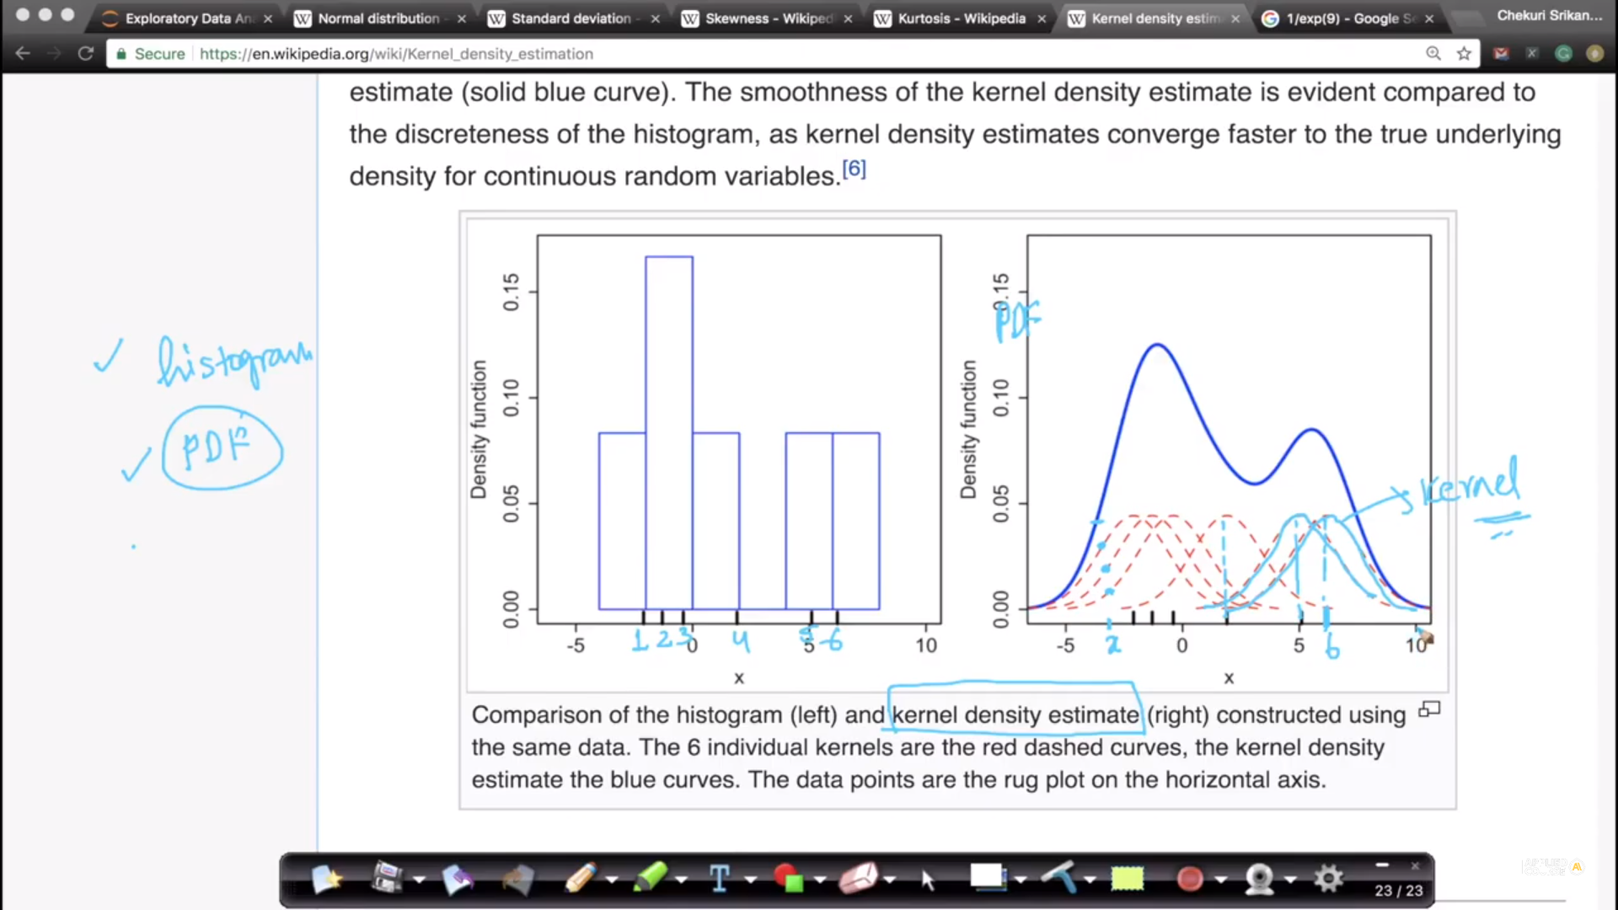

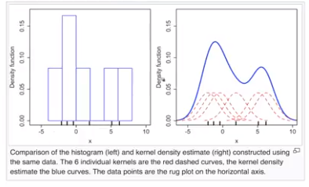

Computing PDF from Histograms: using KDE;

A Gaussian Kernel is plotted centered at each observation (of the histogram);

Variance of this Kernel (bell curve) is called band width;

At every point in the range of the Gaussian Kernels we will add all PDF values to get a combined PDF; bandwidth selection is done by experts;

<https://soundcloud.com/applied-ai-course/kde-and-gaussian-kernel>

from comemnts:

Lets say we have 100 data points, and we are taking a sample of 10 data points from the population of 100 DP. For each of those 10 data points, there will be a mean and variance, which will be a gaussian distribution centered around the respective mean values. However, since we have to calculate the PDF of the entire population, we have to sum of these individual density estimates, so that no one point can claim to be the actual mean of the distribution, instead we will get a probability estimate of the entire dataset.

# **12.8 Sampling distribution & Central Limit theorem**

Definition of Cetral limit theorem:

The sampling distribution of the sample means approaches a normal distribution as the sample size gets larger — *no matter what the shape of the population distribution.*

Let’s phrase it in plain English maybe (sorry statisticians):

If you sample batches of data from any distribution and take the mean of each batch. Then the distribution of the means is going to resemble a Gaussian distribution. (Same goes for taking the sum)

Let X be a not necessarily Gaussian distribution of a population (say incomes)

Pick m random Samples independently of size **n** each 🡪 S1, S2, S3, …., Sm

For all Samples: compute means, x1m, x2m, x3m, ……

These sample means will have a distribution: Sampling distribution of sample-mean

Central Limit Theorem: If X (original population), X: finite mean and variance

Sampling distribution of sample means will be a Gaussian distribution with mean = population mean and variance = population variance/**n** as n increases

It is generally observed that if n is around 30 and m = 1000, we can observe a Gaussian distribution;

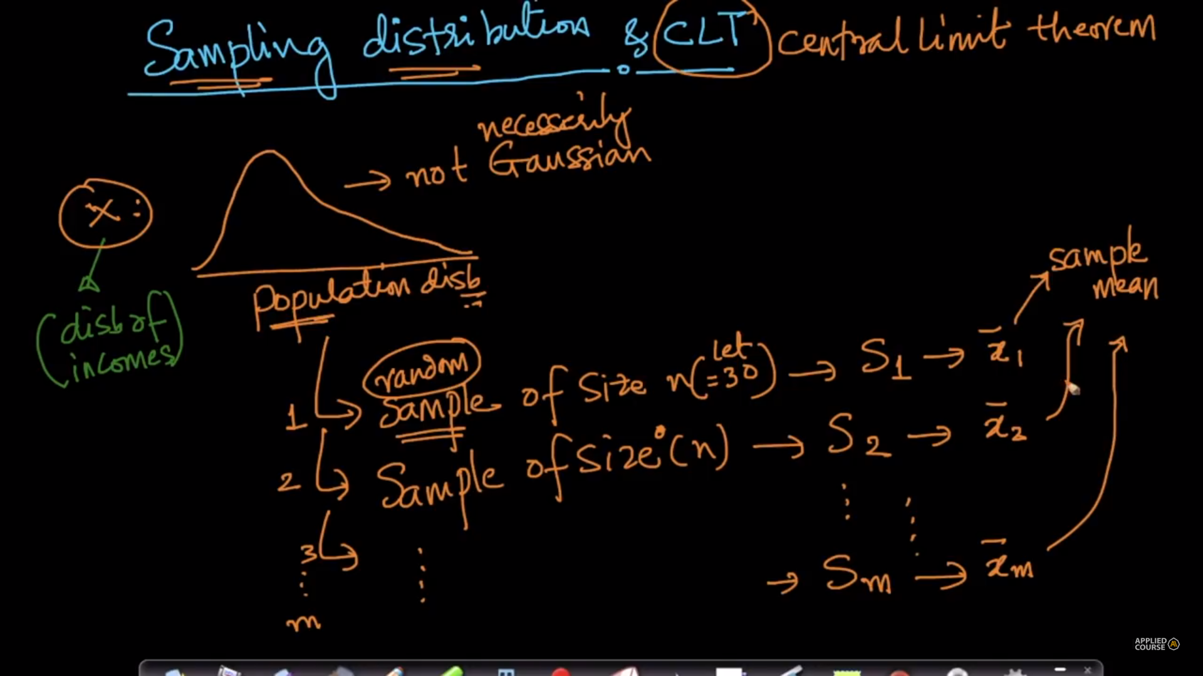

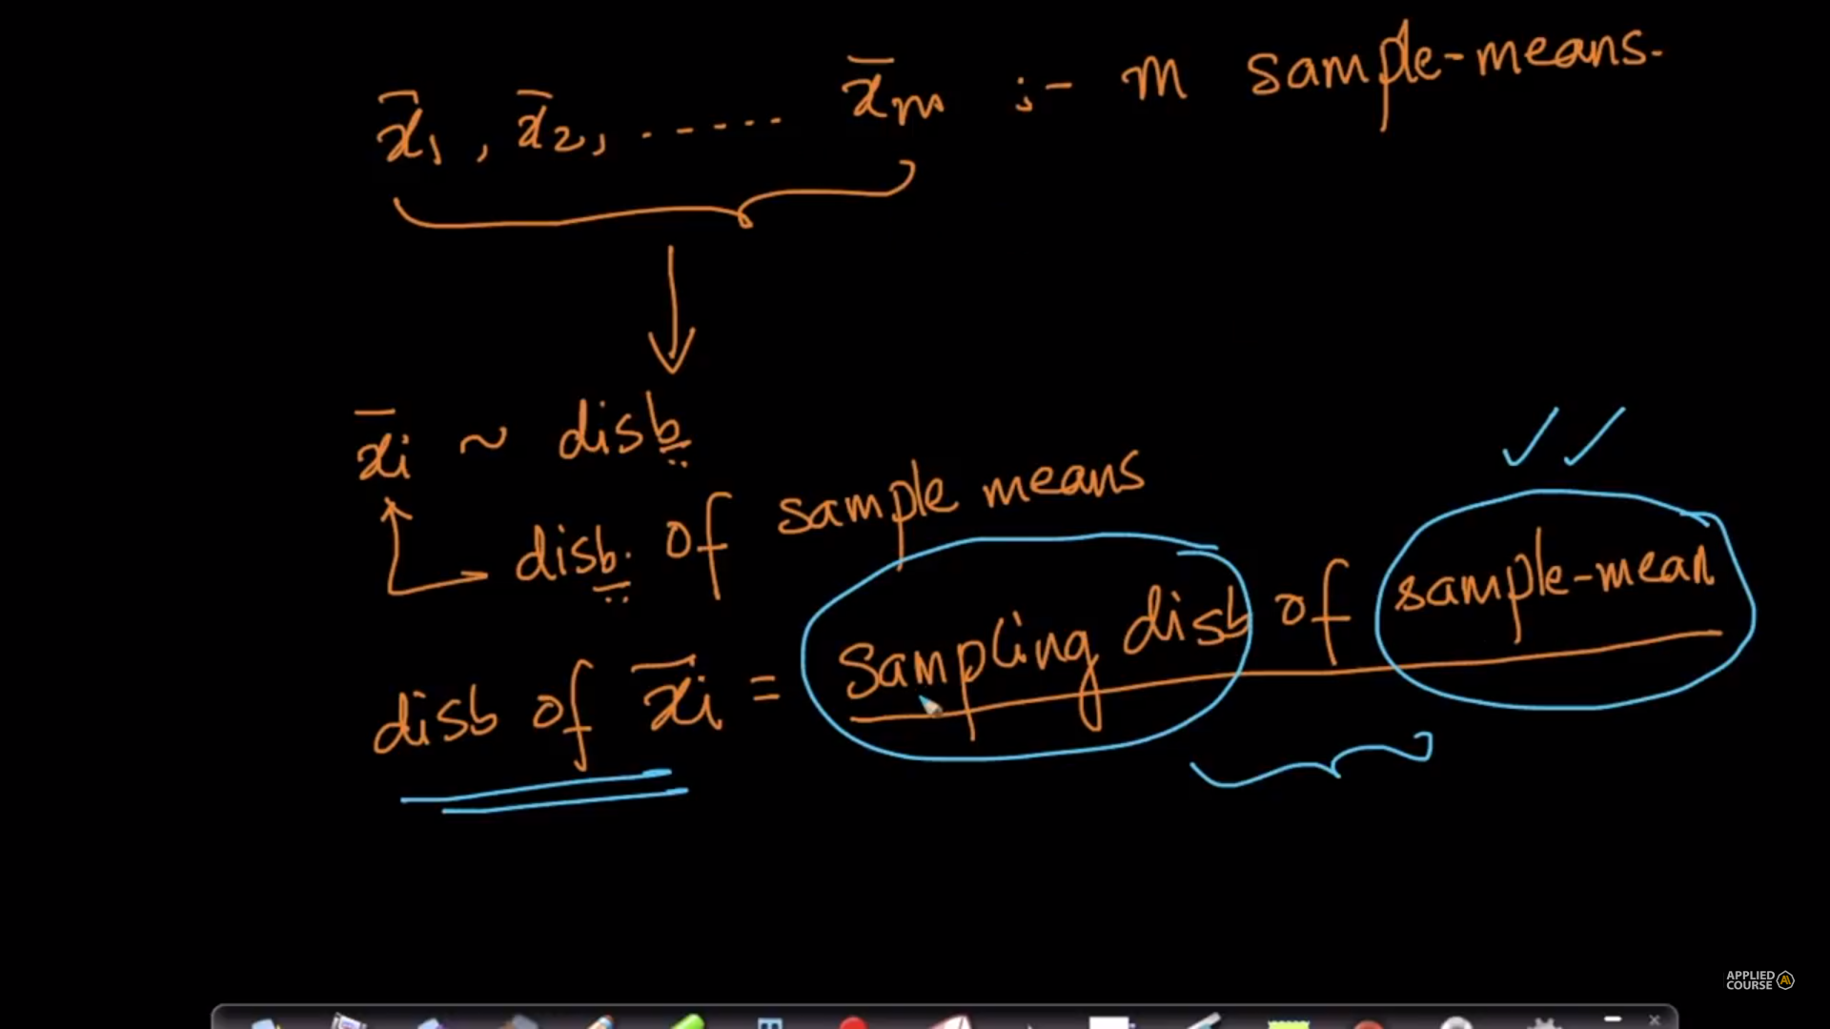

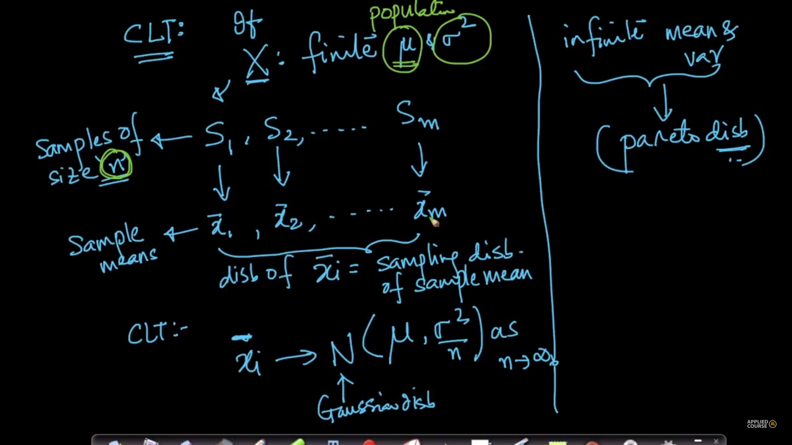

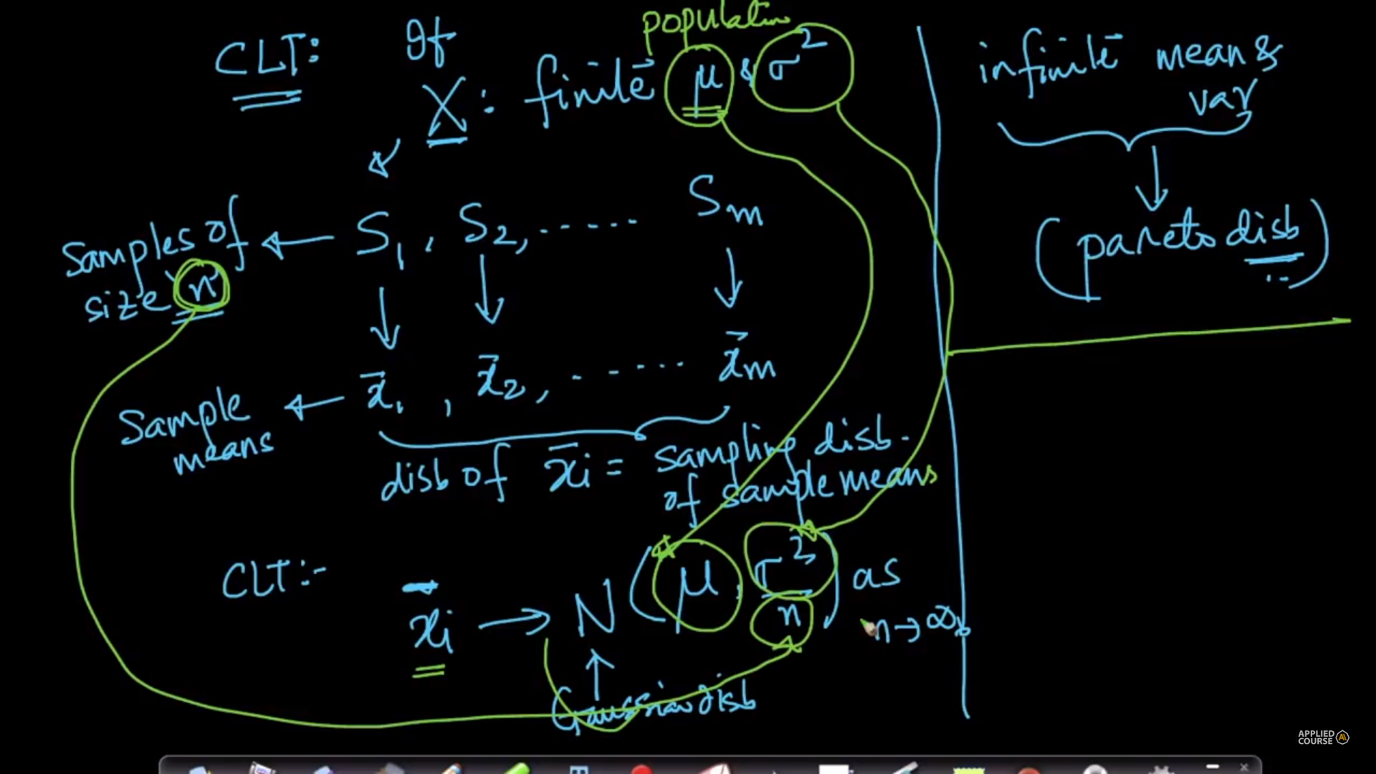

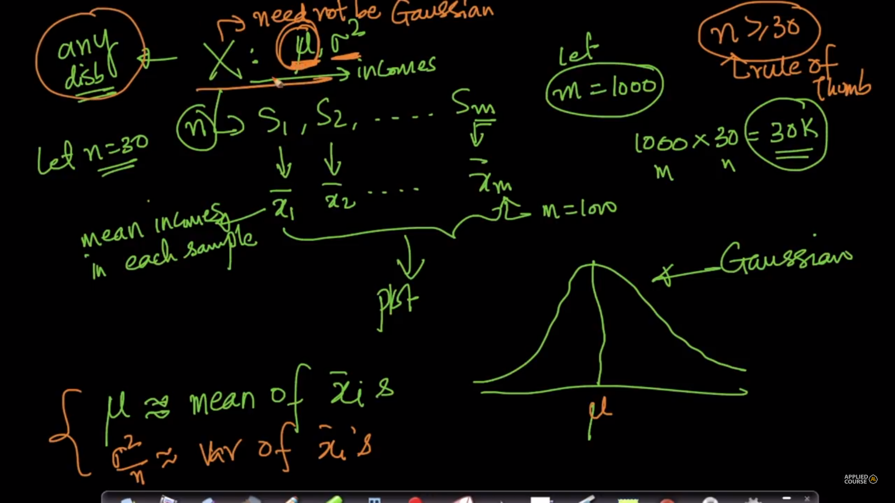

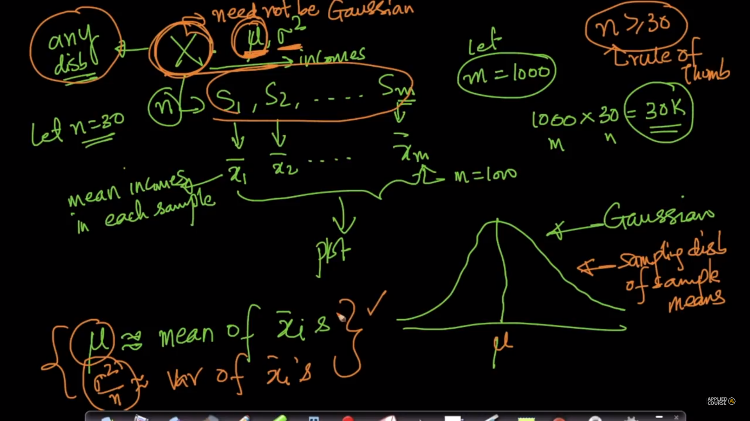

# **12.9 Q-Q plot: How to test if a random variable is normally distributed or not?**

<https://towardsdatascience.com/what-in-the-world-are-qq-plots-20d0e41dece1?gi=186f3b95a58d>

Quantile – Quantile plot: Graphical way of determining similarity between two distributions

The “QQ” in QQ plot means quantile-quantile — that is, **the QQ plot compares the quantiles of our data against the quantiles of the desired distribution** (defaults to the normal distribution, but it can be other distributions too as long as we supply the proper quantiles).

**Quantiles are breakpoints that divide our numerically ordered data into equally proportioned buckets.**

**Steps: from applied ai**

X: a new distribution: Task: to understand whether X is Gaussian

1. Sort X values and compute percentiles;
2. Y ~ N(0,1): take some k observations and sort + compute percentiles
3. Plot: X percentile values on Y axis and Y percentile values on x axis

If the plot is approximately a straight line then the distributions are similar

If the plot is approximately a straight line then the distributions are similar;

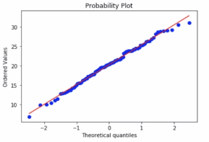

Code: stats.probplot(X, dist = ‘norm’, plot = pylab)

If number of observations is small it is hard to interpret QQ plot;

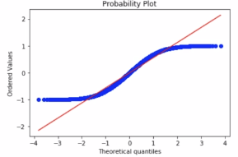

Plot where distributions are different;

Limitaion: if number of observations are small,its hard to interpret QQ plot

Below are screen shots from applied ai class:

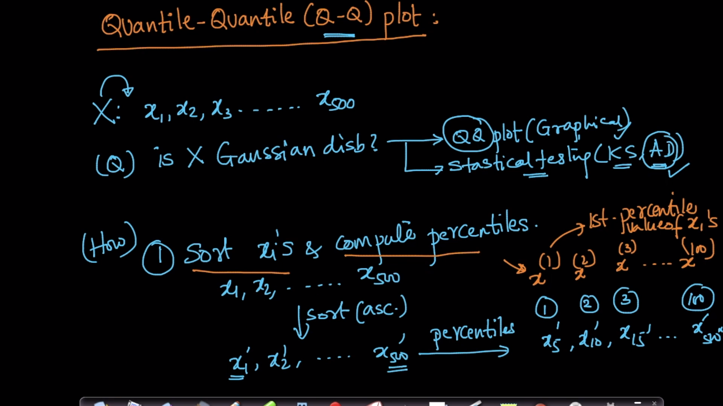

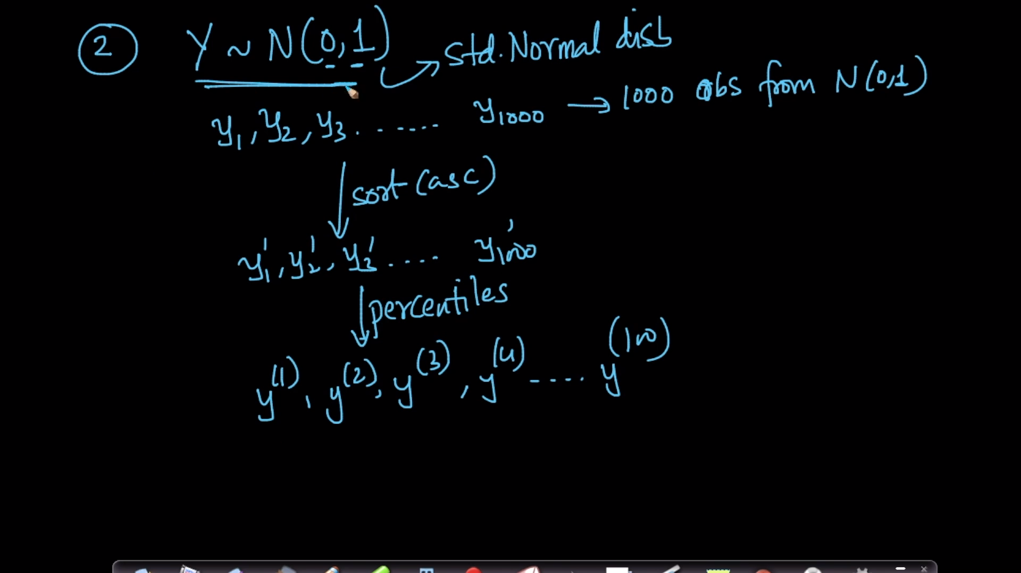

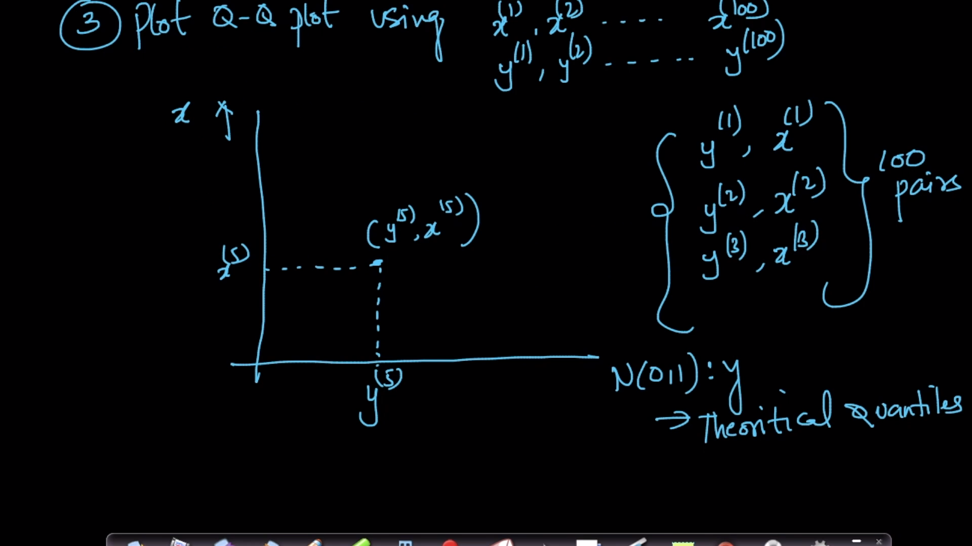

Example :plot where both distributions are same

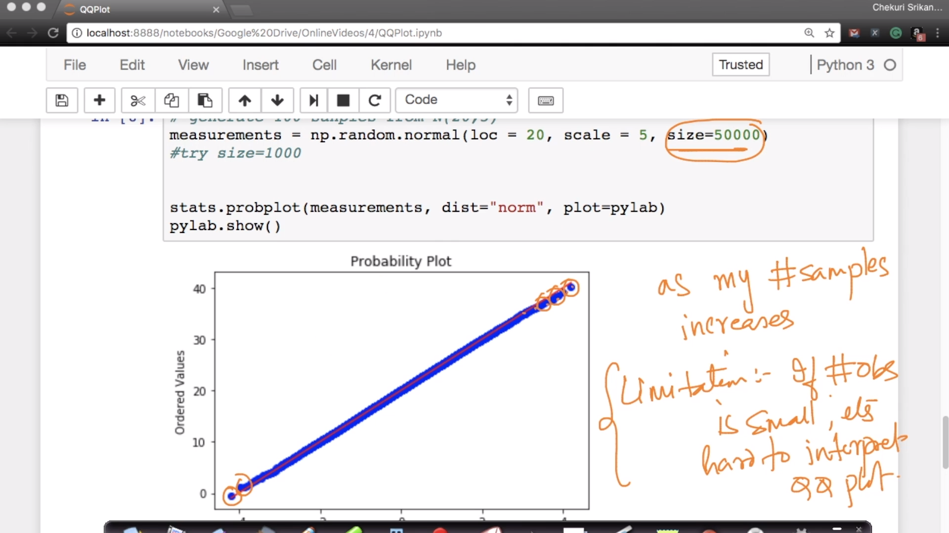

Below image is for where distributions are different.

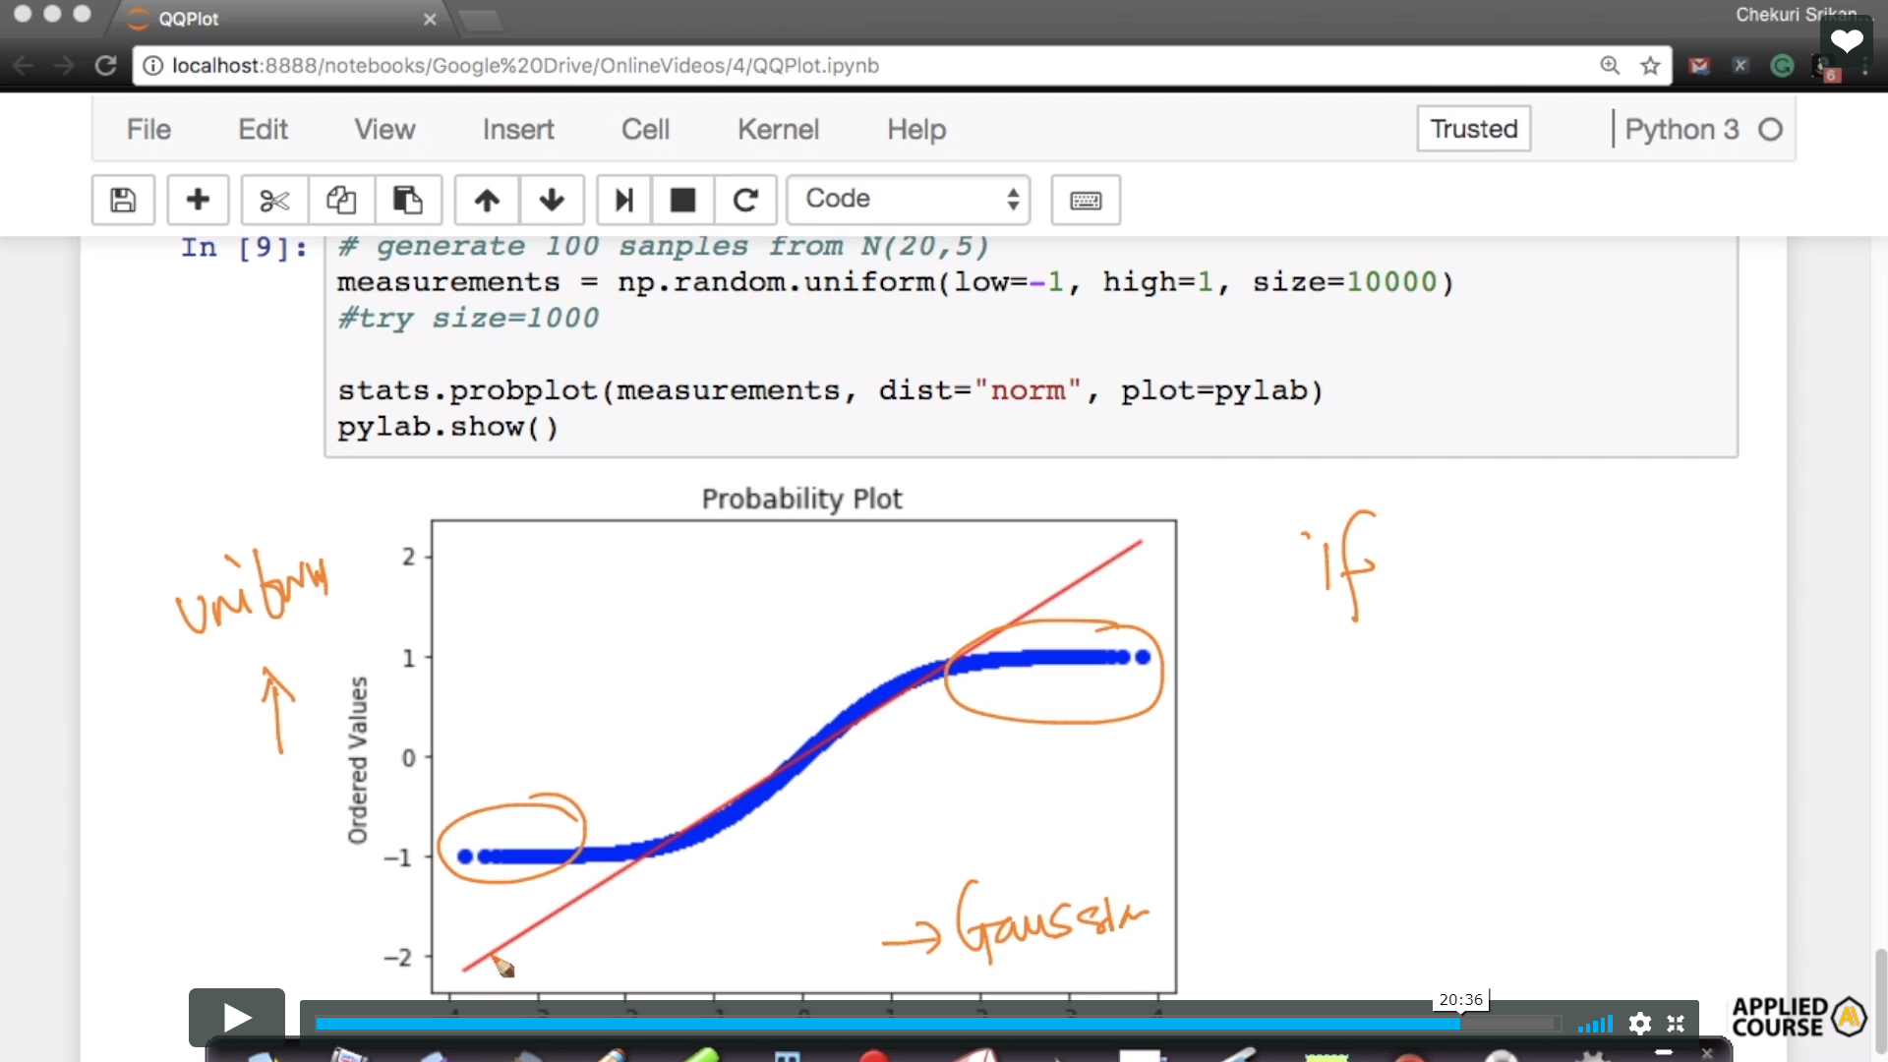

By increasing the sample size of observations, our sample-percentiles become closer to population-percentiles and hence our sample is more guaranteed to be Gaussian. Hence, the QQ-plot looks better when the sample size is larger.  
Audio reply: <https://soundcloud.com/applied-ai-course/qq-plot-vs-sample-size>

From comment sections:

In first case we took X as normal distributed and also Y is normal distributed that's mean X should be Gaussian distributed.  
In second case X is uniform distributed and Y is normal distributed then X should not be Gaussian Distributed.  
For both the case why we are checking X is Gaussian distributed or not as we already know X is Gaussian distributed and Uniform distributed.  
What I understood from Q-Q plot, suppose we have one column "Age" and I am not sure about Age is Gaussian distributed or uniform distributed or any other. Then I will plot the age with one Y ~N(0,1). If all(max) the observation would be on straight line then Age would say Gaussian distributed.

# **12.10 How distributions are used?**

Probability is useful for data analysis;

Ex: Imagine your task is to order T shirts for all employees at your company. Let sizes be S, M, L and XL. Say we have 100k employees who have different size requirements;

Q) How many XL T shirts should be ordered?

Collect data for all 100k employees

Let us have a relationship between heights and T shirt size; Domain knowledge;

Collect heights from 500 random employees; Compute mean and std dev

At gate of entry we can do this;

From domain knowledge, let heights ~N(mean, variance)

We can extend the distribution of heights from 500 employees to 100k employees; We made many assumptions here; these may work in natural features

Q) Salaries: If salaries are Gaussian distributed, we can estimate how many employees make a salary > 100k $;

So distributions give us a theoretical model of a random variable; This will help us understand the properties of the random variable;

# **12.11 Chebyshev’s inequality**

If we don’t know the distribution and mean is finite and standard deviation is non-zero and finite;

Task: to find the percentage of values of lie within a range;

Salaries of individuals (millions of values); distribution is unknown, but mean and std dev are known;

P(|x - µ| >= kσ) <= 1/k2

refer : <https://medium.com/analytics-vidhya/illustration-with-python-chebyshevs-inequality-b34be151c547>

<https://en.wikipedia.org/wiki/Chebyshev%27s_inequality#Probabilistic_statement>

<https://www.quora.com/What-is-a-real-world-application-of-Chebyshevs-inequality>

REFER :  <https://youtu.be/GMDvuzfNxzI>

The Chebyshev’s inequality states that, for wide class of probability distribution, no more than a certain amount of values can be more than a certain distance from the mean, with the formula as follow.

K is the number of standard deviations.

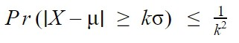

Where X is a random variable, μ is an expected value of X, σ is a standard deviation of X and k > 0.

For example, the probability that a distance from an expected value is far more than 3 standard deviation is less or equal than one over nine.

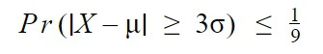

According to the formula, if k increases

Below are from appliedai

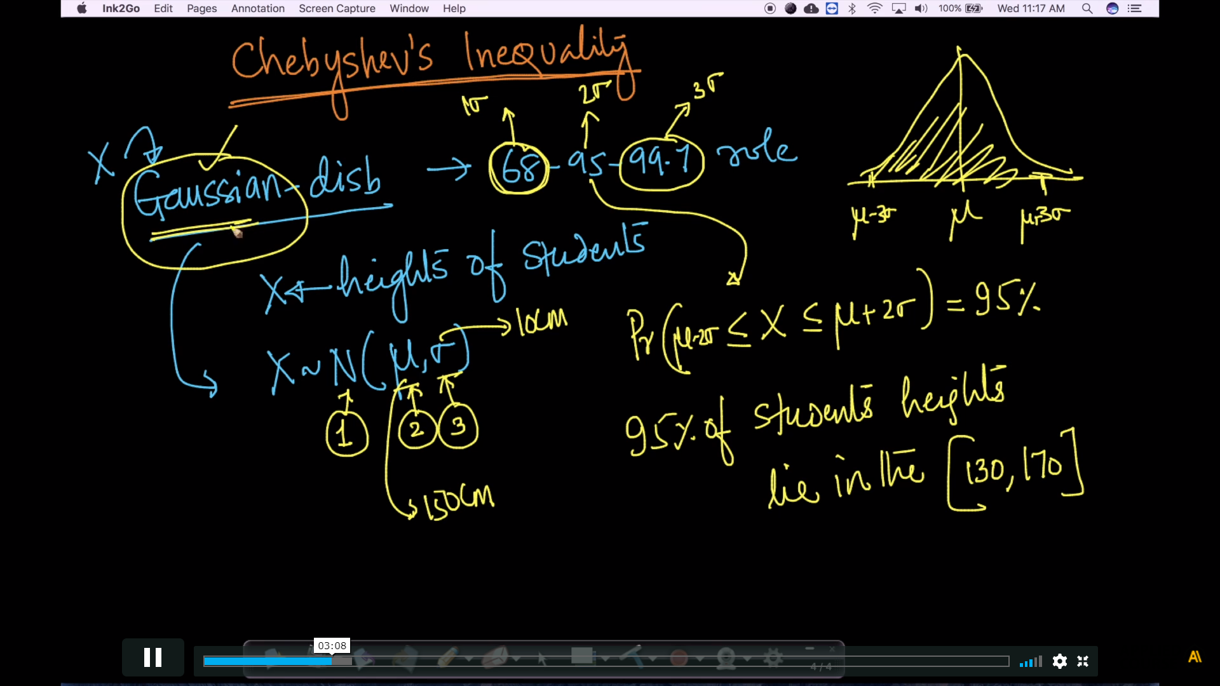

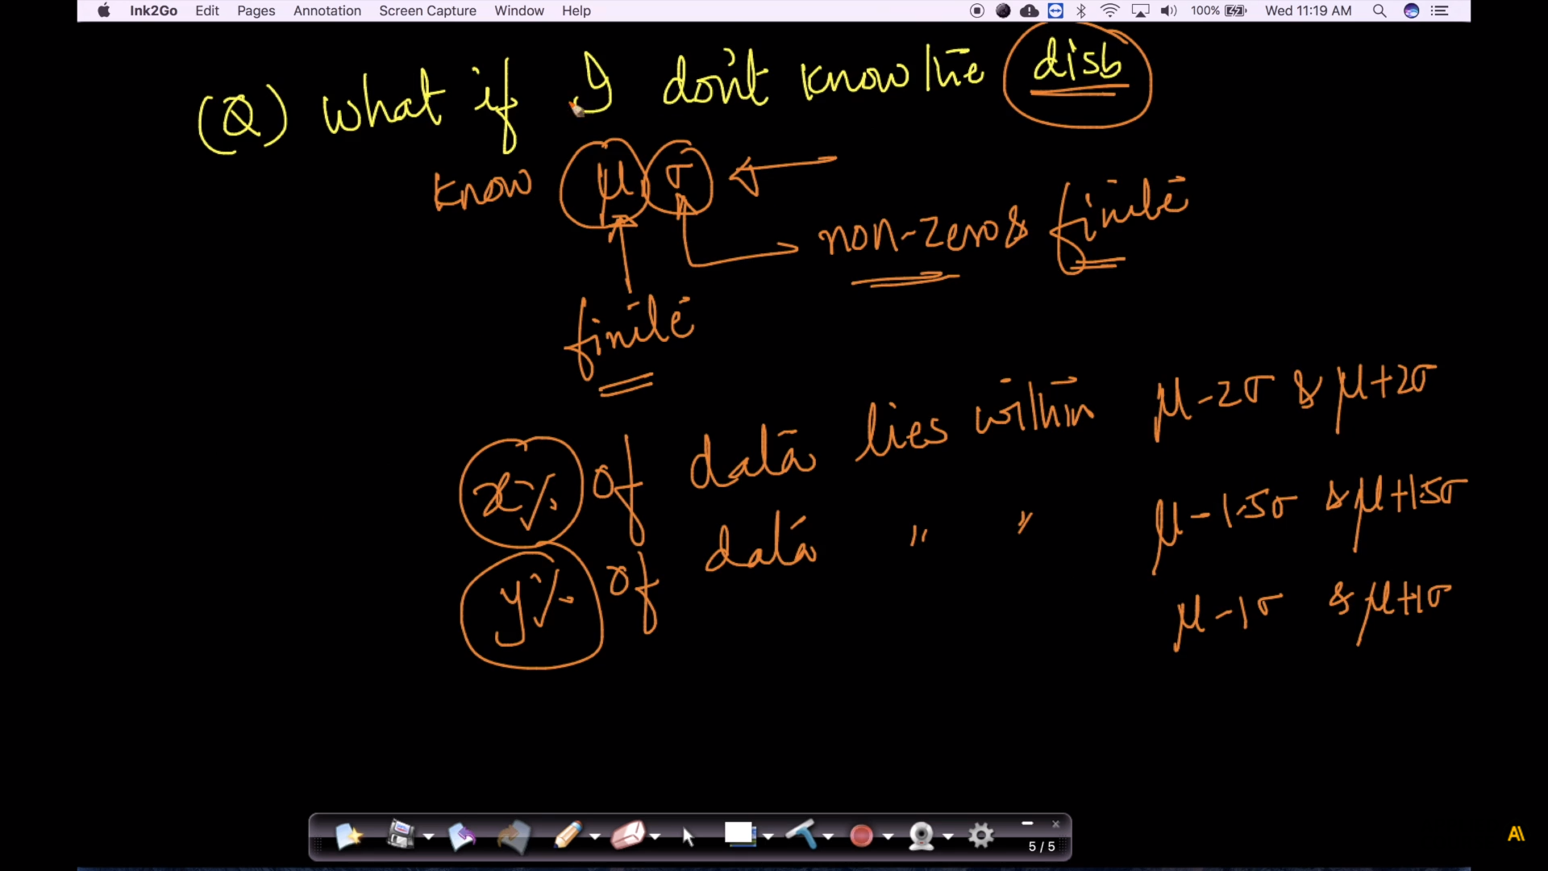

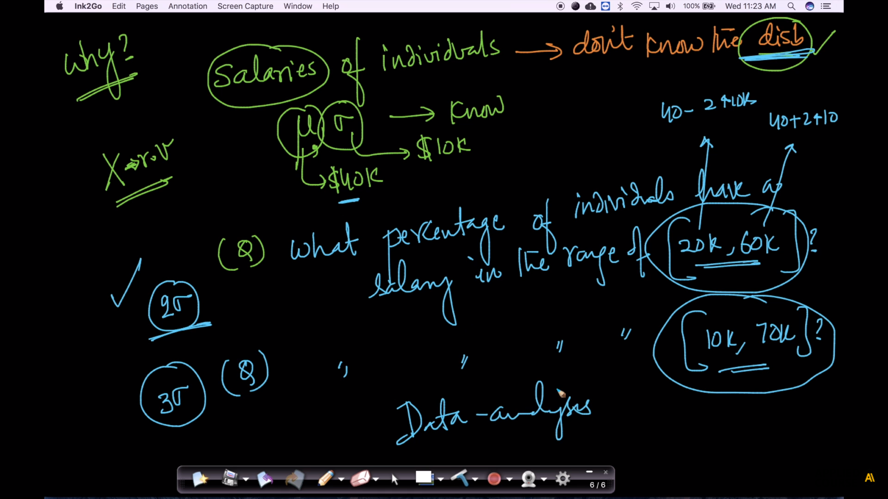

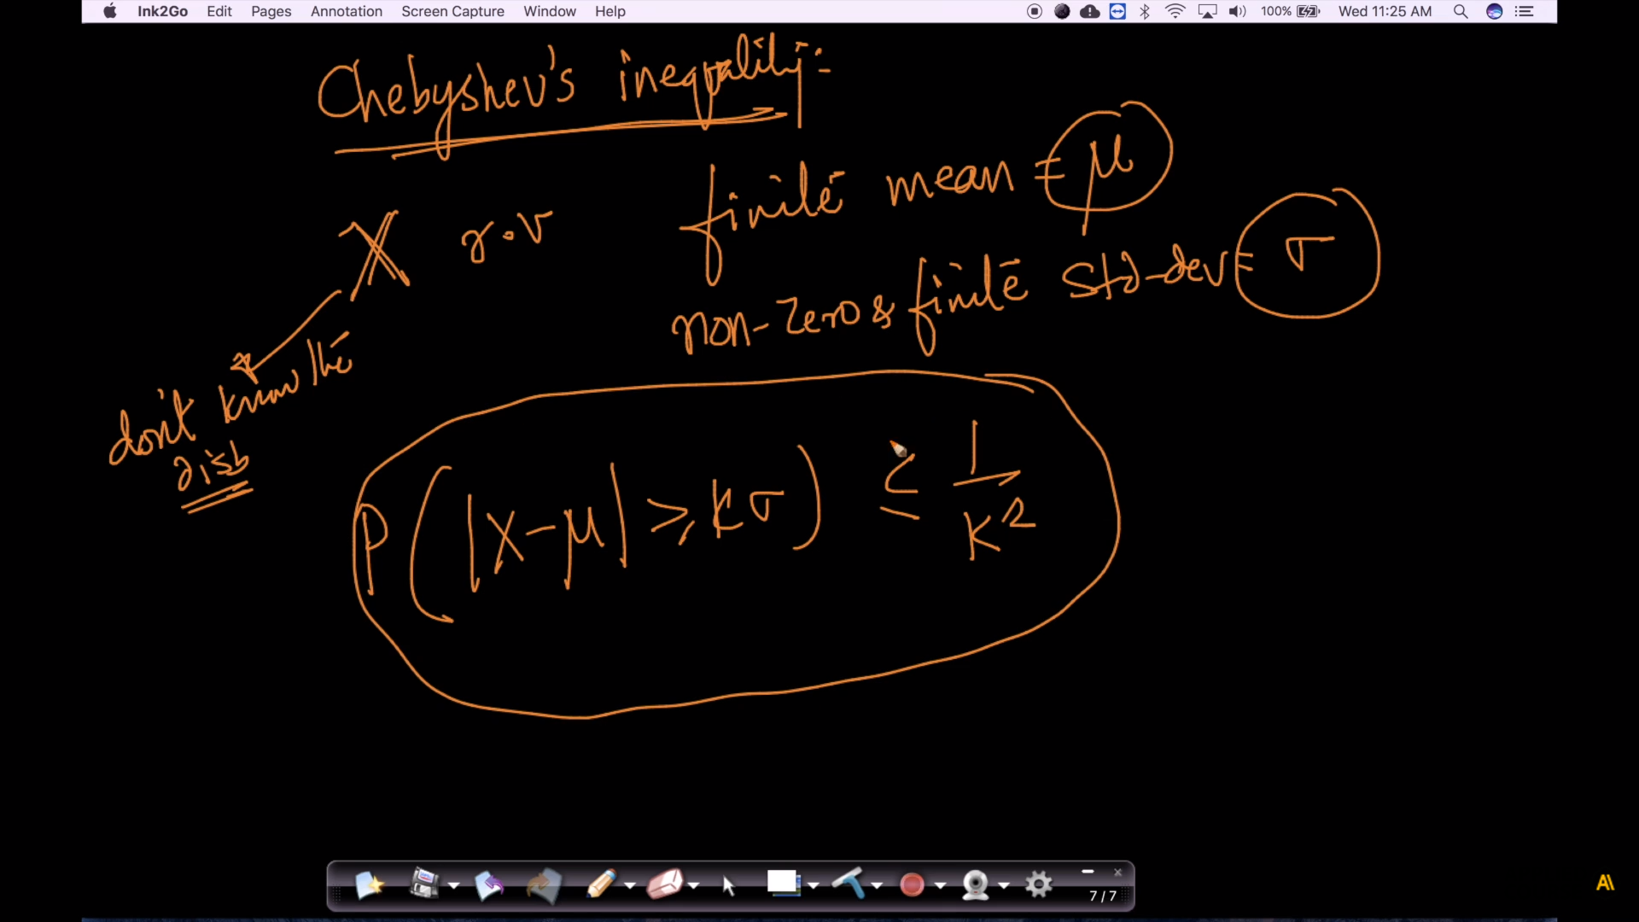

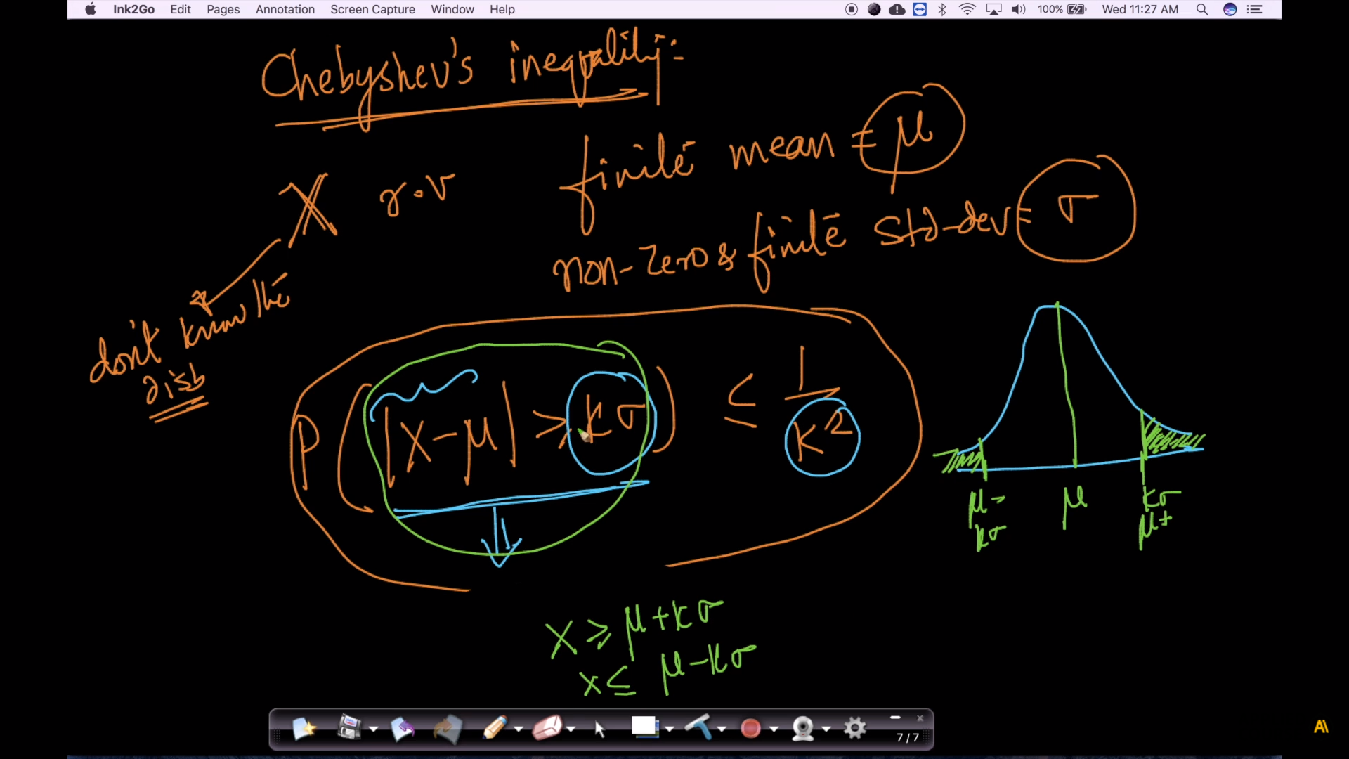

In below image formula is :  P( µ -kσ  <  X  <    µ+ kσ )   >= 1 -  1 /*k*2

P(|x - µ| >= kσ) <= 1/k2

Is same as   
P(µ - kσ < x < µ +k*σ ) >= 1 - 1/k2

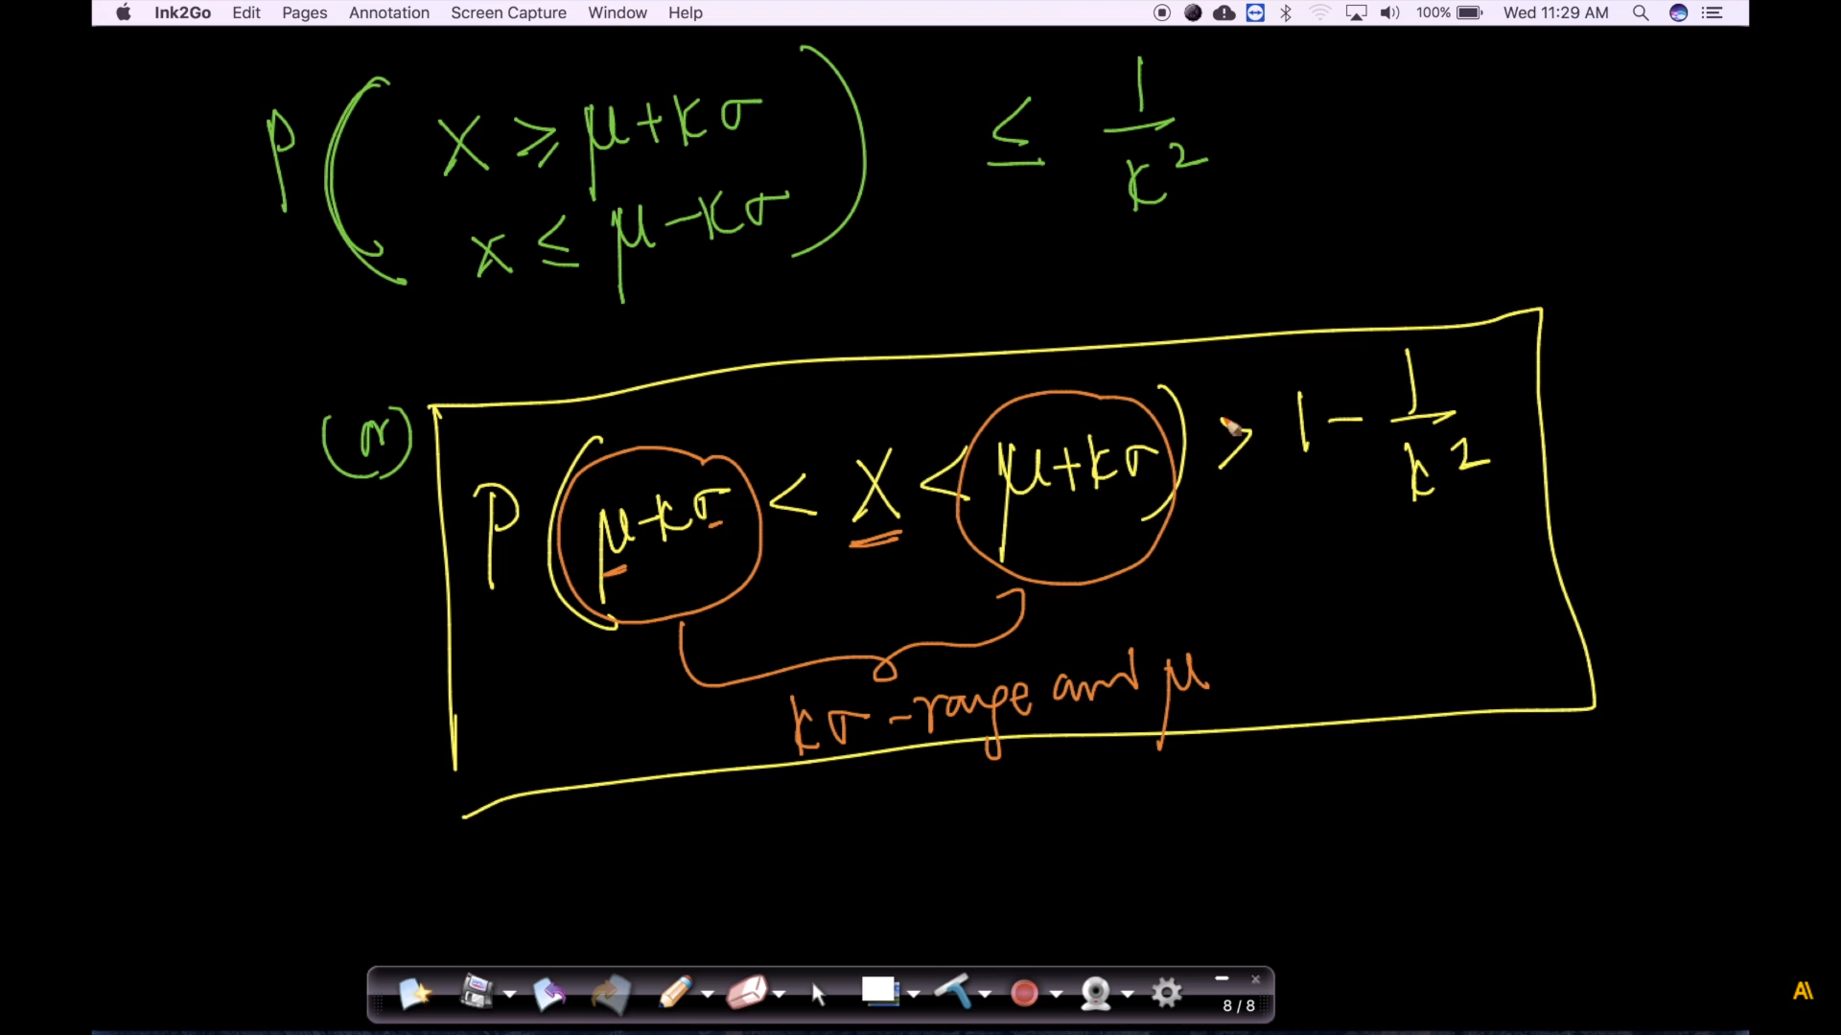

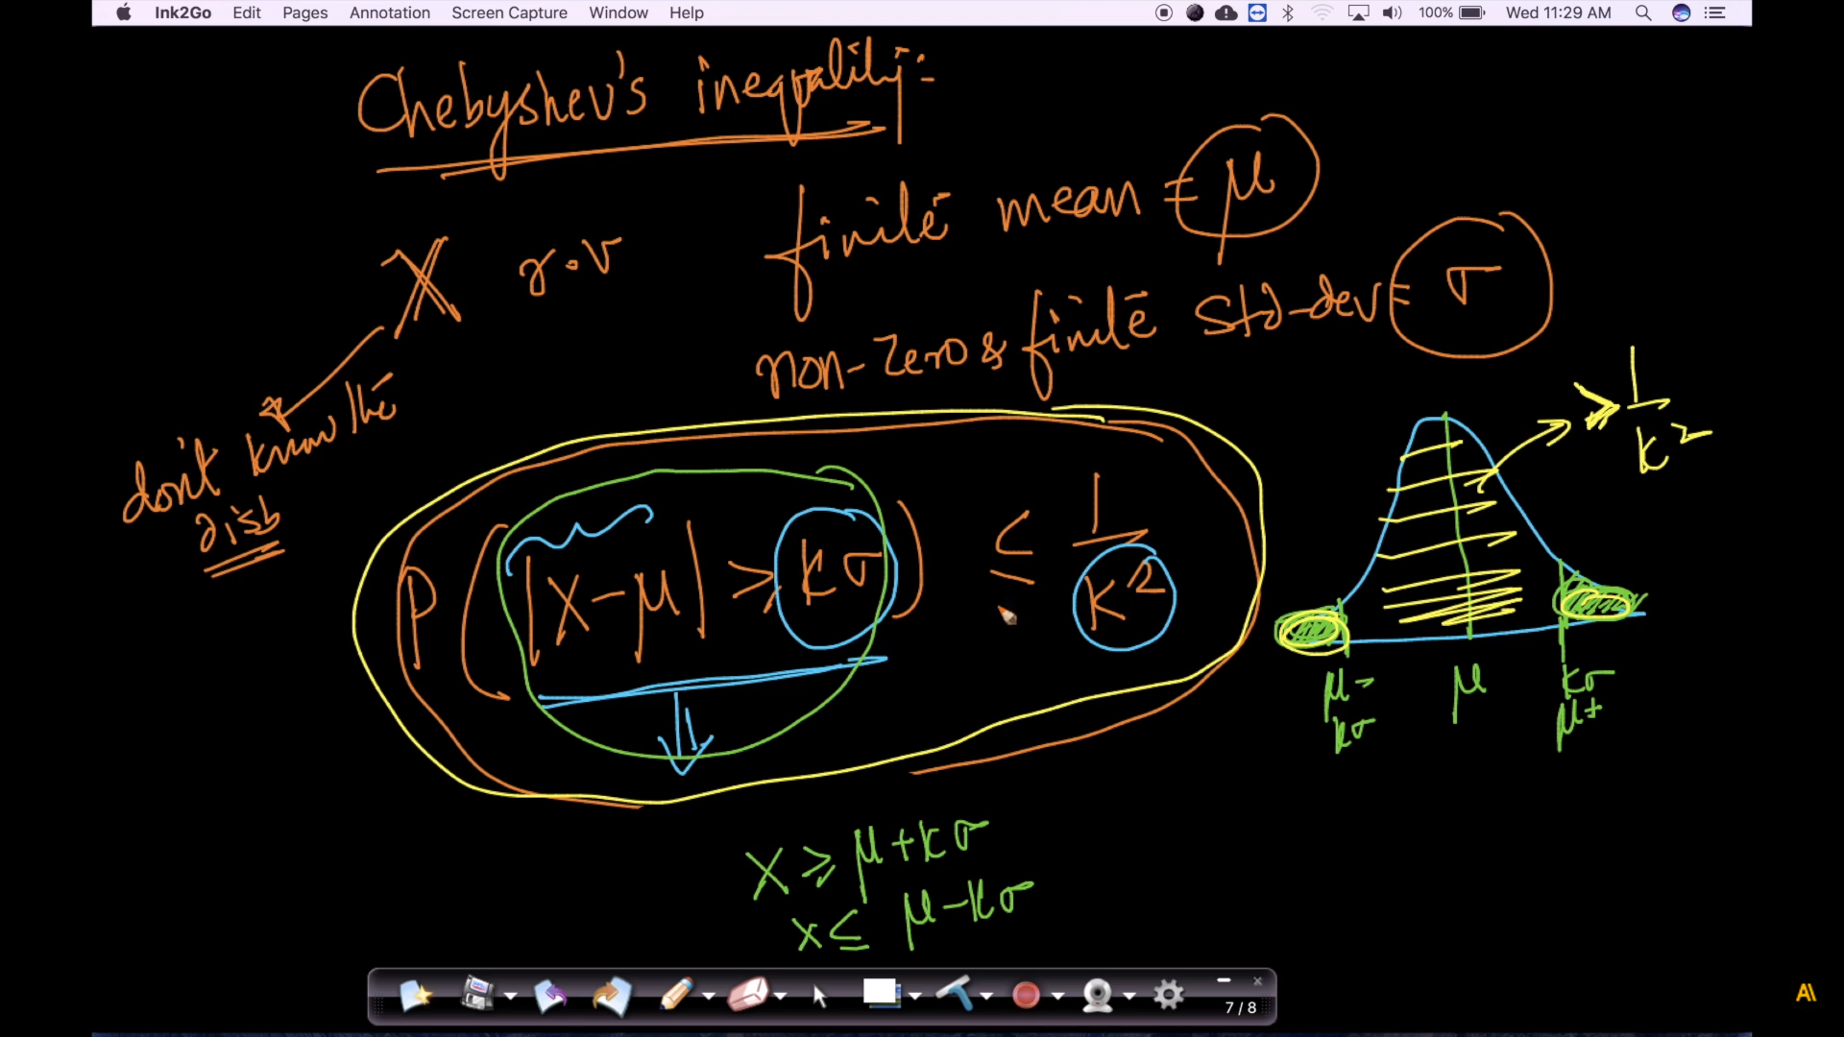

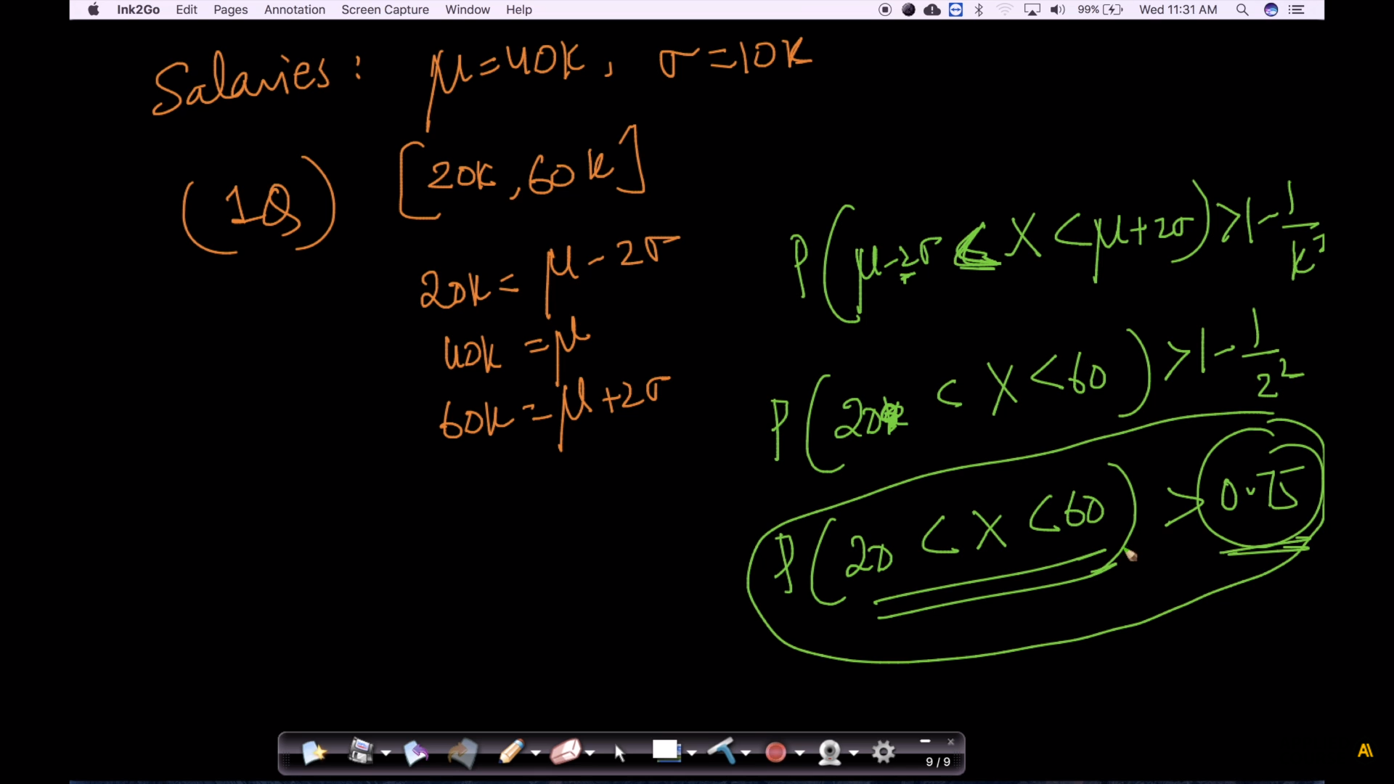

Now we can answer question1 as >75%

if it follws Gaussian distribution then it should be 95 but this is not Gaussian so found that it is more than >75%

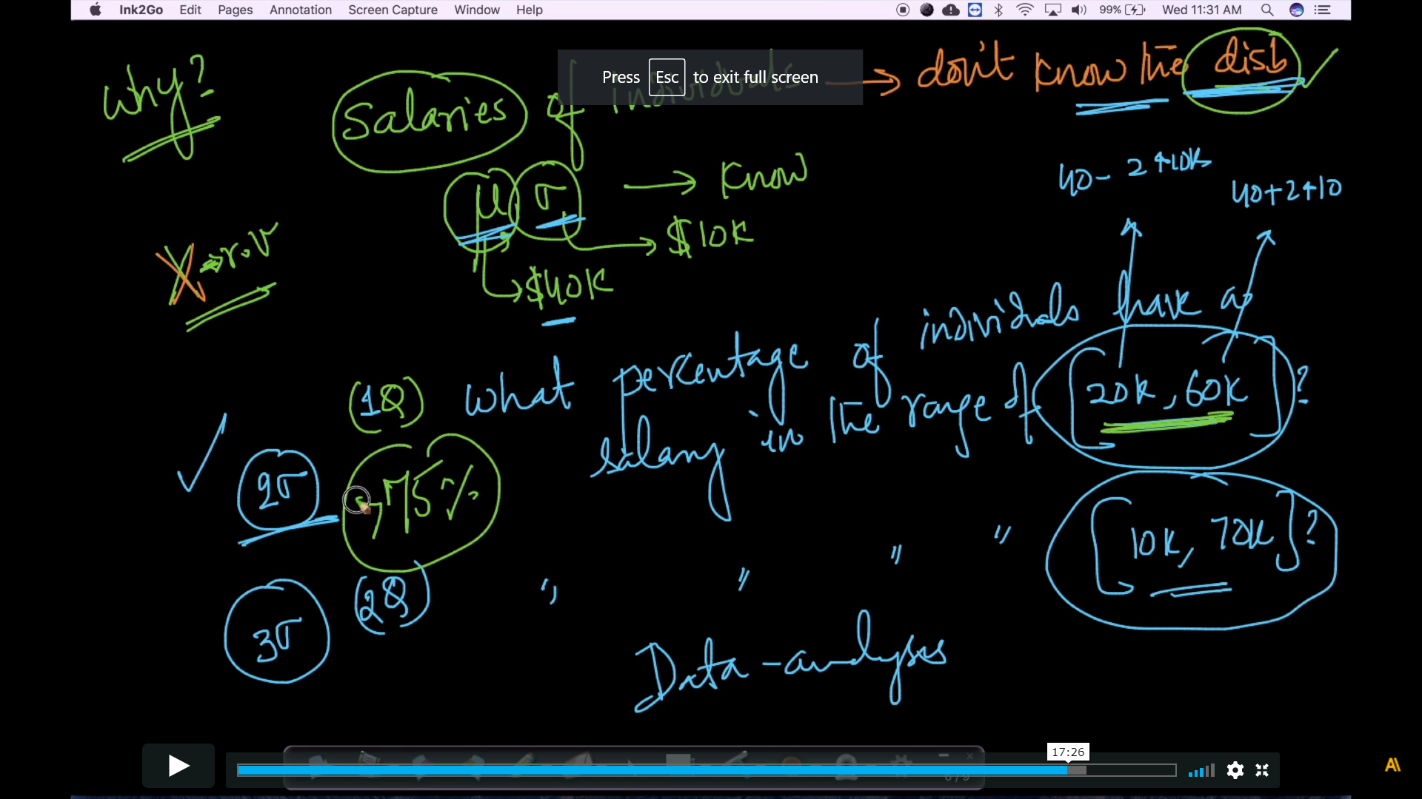

For 2nd questions 1- 1/(square(3) = 1- 1/9 =8/9 => 90%

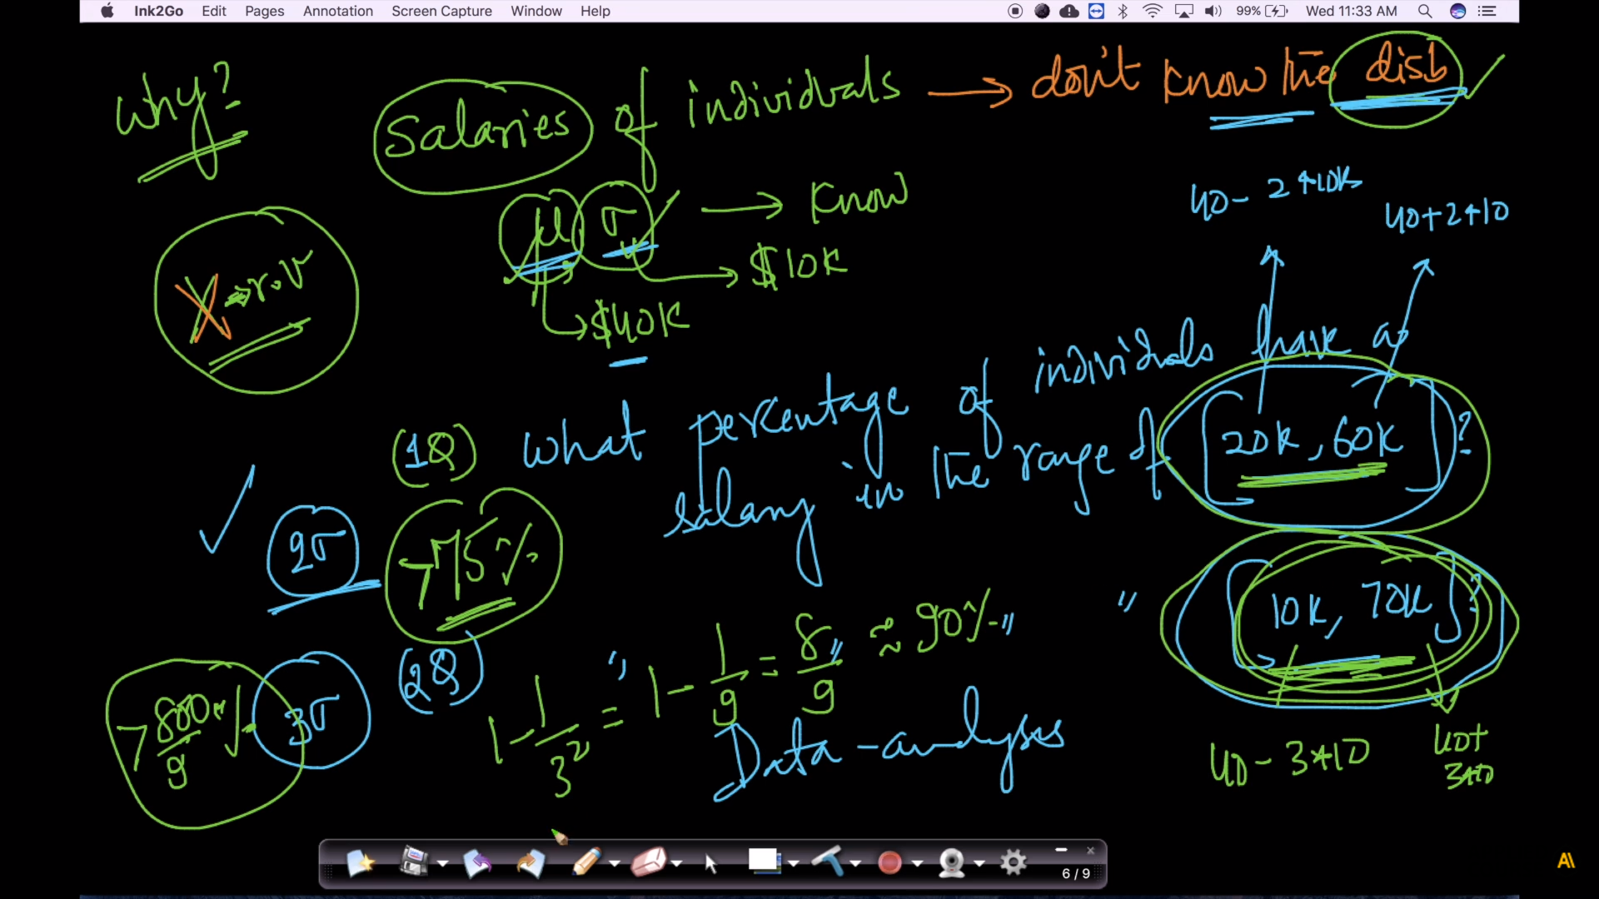

Below screen shots are from follow up video youtube:

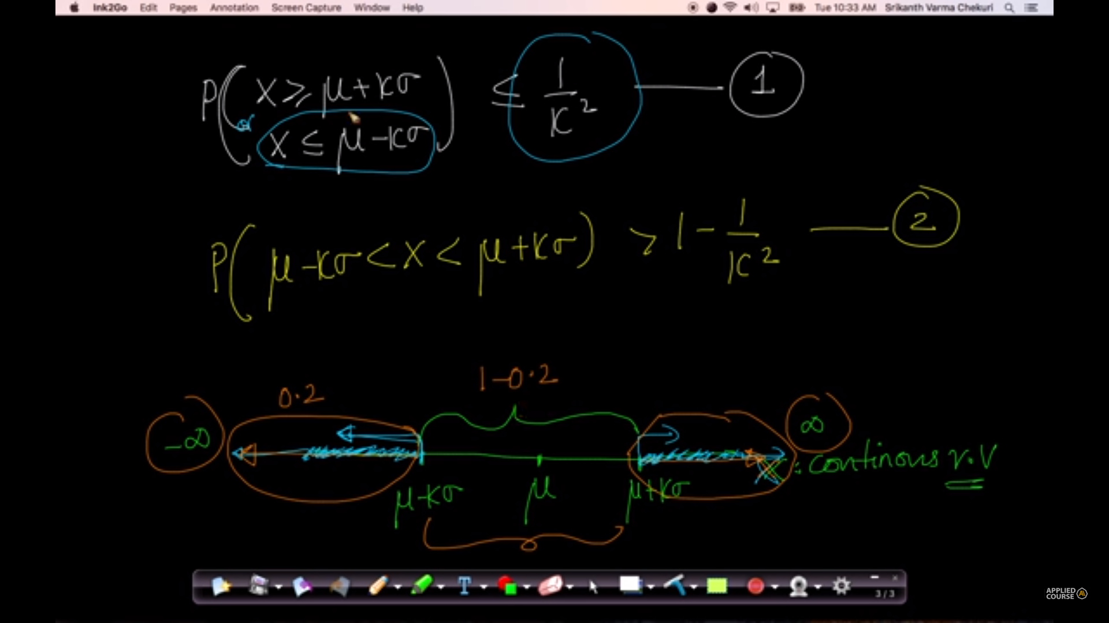

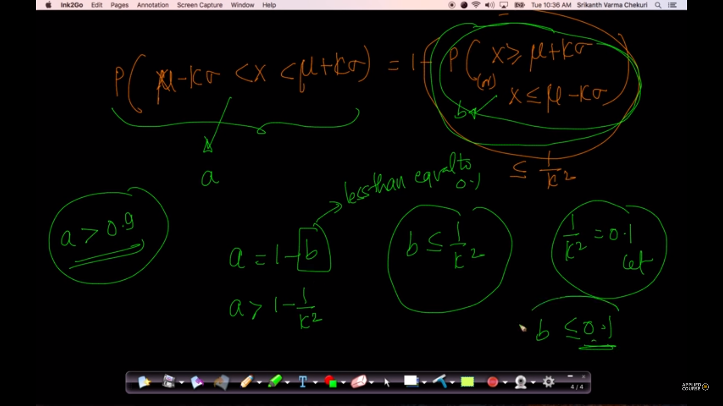

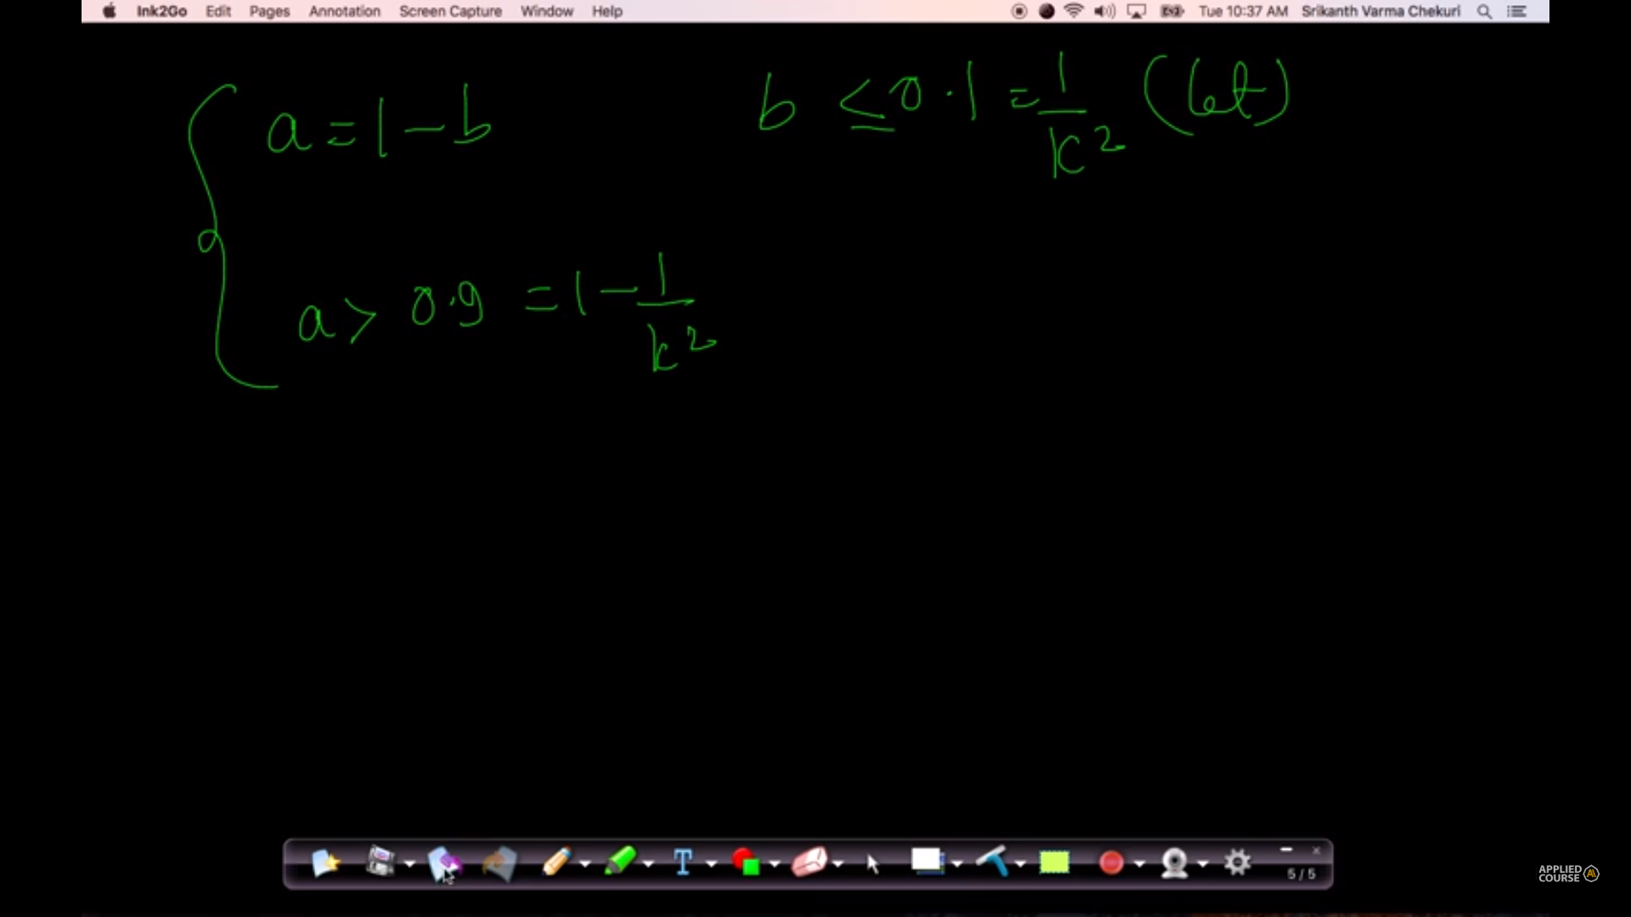

From applied ai comments :

* chebyshev's inequality doesn't says anything about the distribution. All is says is what minimum percentage of points lie between k- standard deviations around the mean
* If any problem given with finite mean and variance. so using chebyshev's theorem atleast we can provide approximation(like minimum value) answer of given problem.

# **12.12 Discrete and Continuous Uniform distributions**

Refer:

<https://en.wikipedia.org/wiki/Uniform_distribution_(continuous)>

<https://en.wikipedia.org/wiki/Discrete_uniform_distribution>

from comment section

<https://soundcloud.com/applied-ai-course/pdf-for-continous-rv>

<https://stats.stackexchange.com/questions/107563/do-the-pdf-and-the-pmf-and-the-cdf-contain-the-same-information>

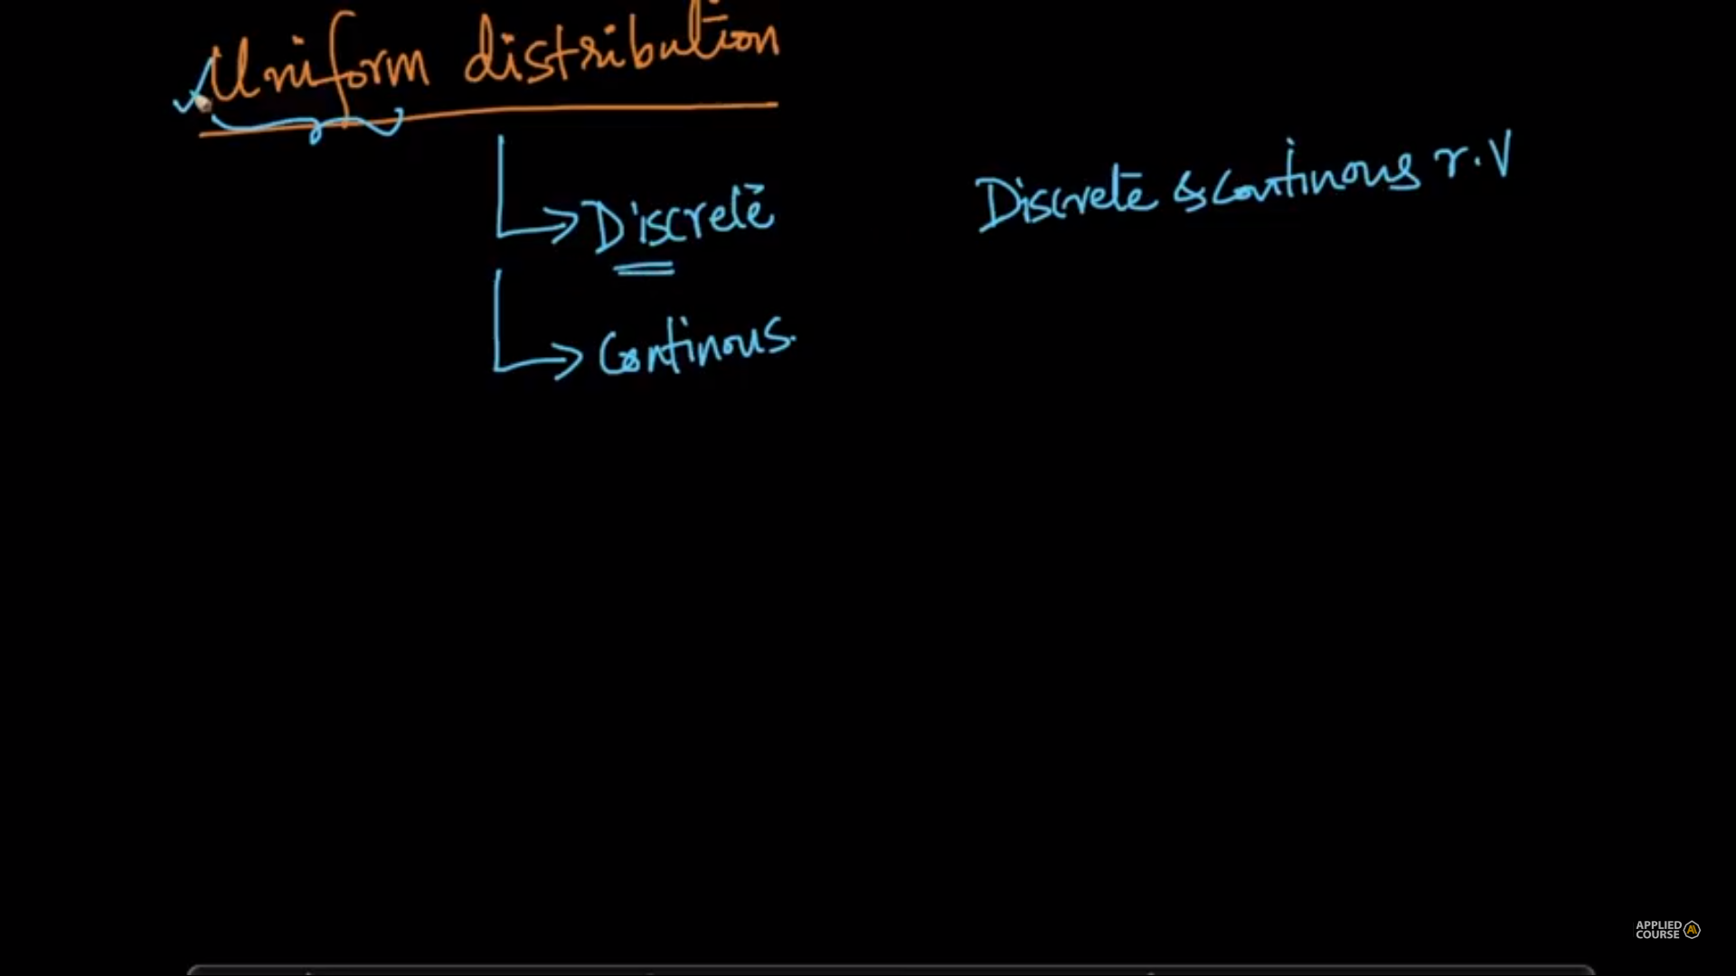

PDF for continuous and PMF for discrete random variables;

Roll a dice: uniform distribution; each observation is equally probable;

**Discrete Uniform**: from wiki

**discrete uniform distribution** is a [symmetric](https://en.wikipedia.org/wiki/Symmetric_distribution) [probability distribution](https://en.wikipedia.org/wiki/Discrete_probability_distribution) wherein a finite number of values are equally likely to be observed; every one of *n* values has equal probability 1/*n*. Another way of saying "discrete uniform distribution" would be "a known, finite number of outcomes equally likely to happen".

A simple example of the discrete uniform distribution is throwing a fair die. The possible values are 1, 2, 3, 4, 5, 6, and each time the die is thrown the probability of a given score is 1/6

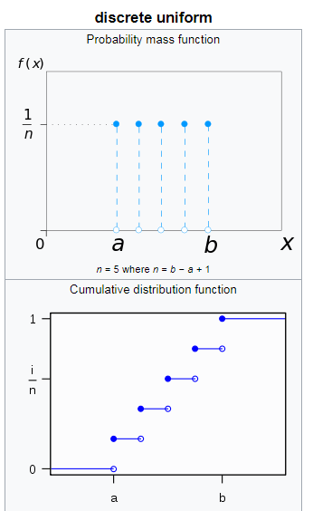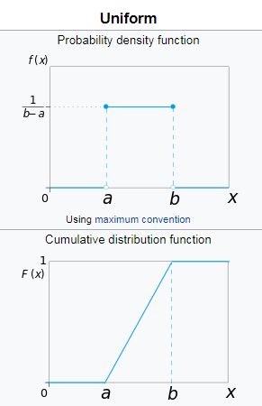

Parameters (a,b,n=b-a+1)

Pmf = 1/n

Mean = (a+b) /2 = Median

Variance = ((b-a+1)2-1)/12

Skewness = 0

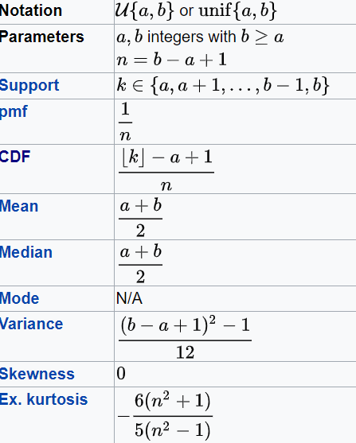

**Continuous Uniform: from wiki**

continuous uniform distribution or rectangular distribution is a family of [symmetric](https://en.wikipedia.org/wiki/Symmetric_distribution) [probability distributions](https://en.wikipedia.org/wiki/Probability_distributions). The distribution describes an experiment where there is an arbitrary outcome that lies between certain bounds.[[1]](https://en.wikipedia.org/wiki/Uniform_distribution_(continuous)#cite_note-:0-1) The bounds are defined by the parameters, a and b, which are the minimum and maximum values. The interval can be either [closed](https://en.wikipedia.org/wiki/Closed_interval) (eg. [a, b]) or [open](https://en.wikipedia.org/wiki/Open_Interval) (eg. (a, b)).[[2]](https://en.wikipedia.org/wiki/Uniform_distribution_(continuous)#cite_note-:3-2) Therefore, the distribution is often abbreviated U (a, b), where U stands for uniform distribution.[[1]](https://en.wikipedia.org/wiki/Uniform_distribution_(continuous)#cite_note-:0-1) The difference between the bounds defines the interval length; all [intervals](https://en.wikipedia.org/wiki/Interval_(mathematics)) of the same length on the distribution's [support](https://en.wikipedia.org/wiki/Support_(mathematics)) are equally probable

Parameter: a,b

PDF: 1/(b-a)

Mean: (a+b)/2 = Median

Variance = (b-a)2/12

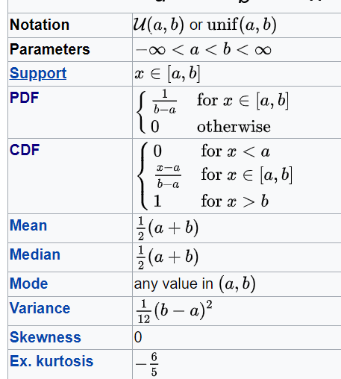

🡪

pdf tells us the density of data whose has the value equal to one which is on the --respective x-axis where as the pmf tells us the probability of finding the value which is on the respective x-axis .

🡪PMF is a function that would give an outcome of a probability of a discrete random variable that is exactly equal to a certain value  
PDF is a function that would give an outcome of probability of a continuous random variable that falls within that range

🡪

n = (b-a+1) for discrete uniform distribution, for it continuous distribution n=(b-a)

🡪

Probability mass functions are used for discrete distributions. It assigns a probability to each point in the sample space. Whereas the integral of a probability density function gives the probability that a random variable falls within some interval.

To know all types of distributions refer :

<https://www.analyticsvidhya.com/blog/2017/09/6-probability-distributions-data-science/>

# **12.13 How to randomly sample data points (Uniform Distribution)**

Refer : <https://www.geeksforgeeks.org/how-to-randomly-select-rows-from-pandas-dataframe/>

Using random functions in python;

We can use a threshold value to generate a random number of random numbers;

Probability of picking any value is equally probable;

here we want to sample 30 data points from population of 150 data points. we are achieving this programmatically as follows. divide sample by population(i.e 30/150 = 0.2) . now take uniform distribution(i.e random.random gives us number between 0 and 1 uniformly).so for 150 data points we take 150 random numbers between 0 and 1 and if number happens to be less than or equal to 0.2 we include that point from population into sample.

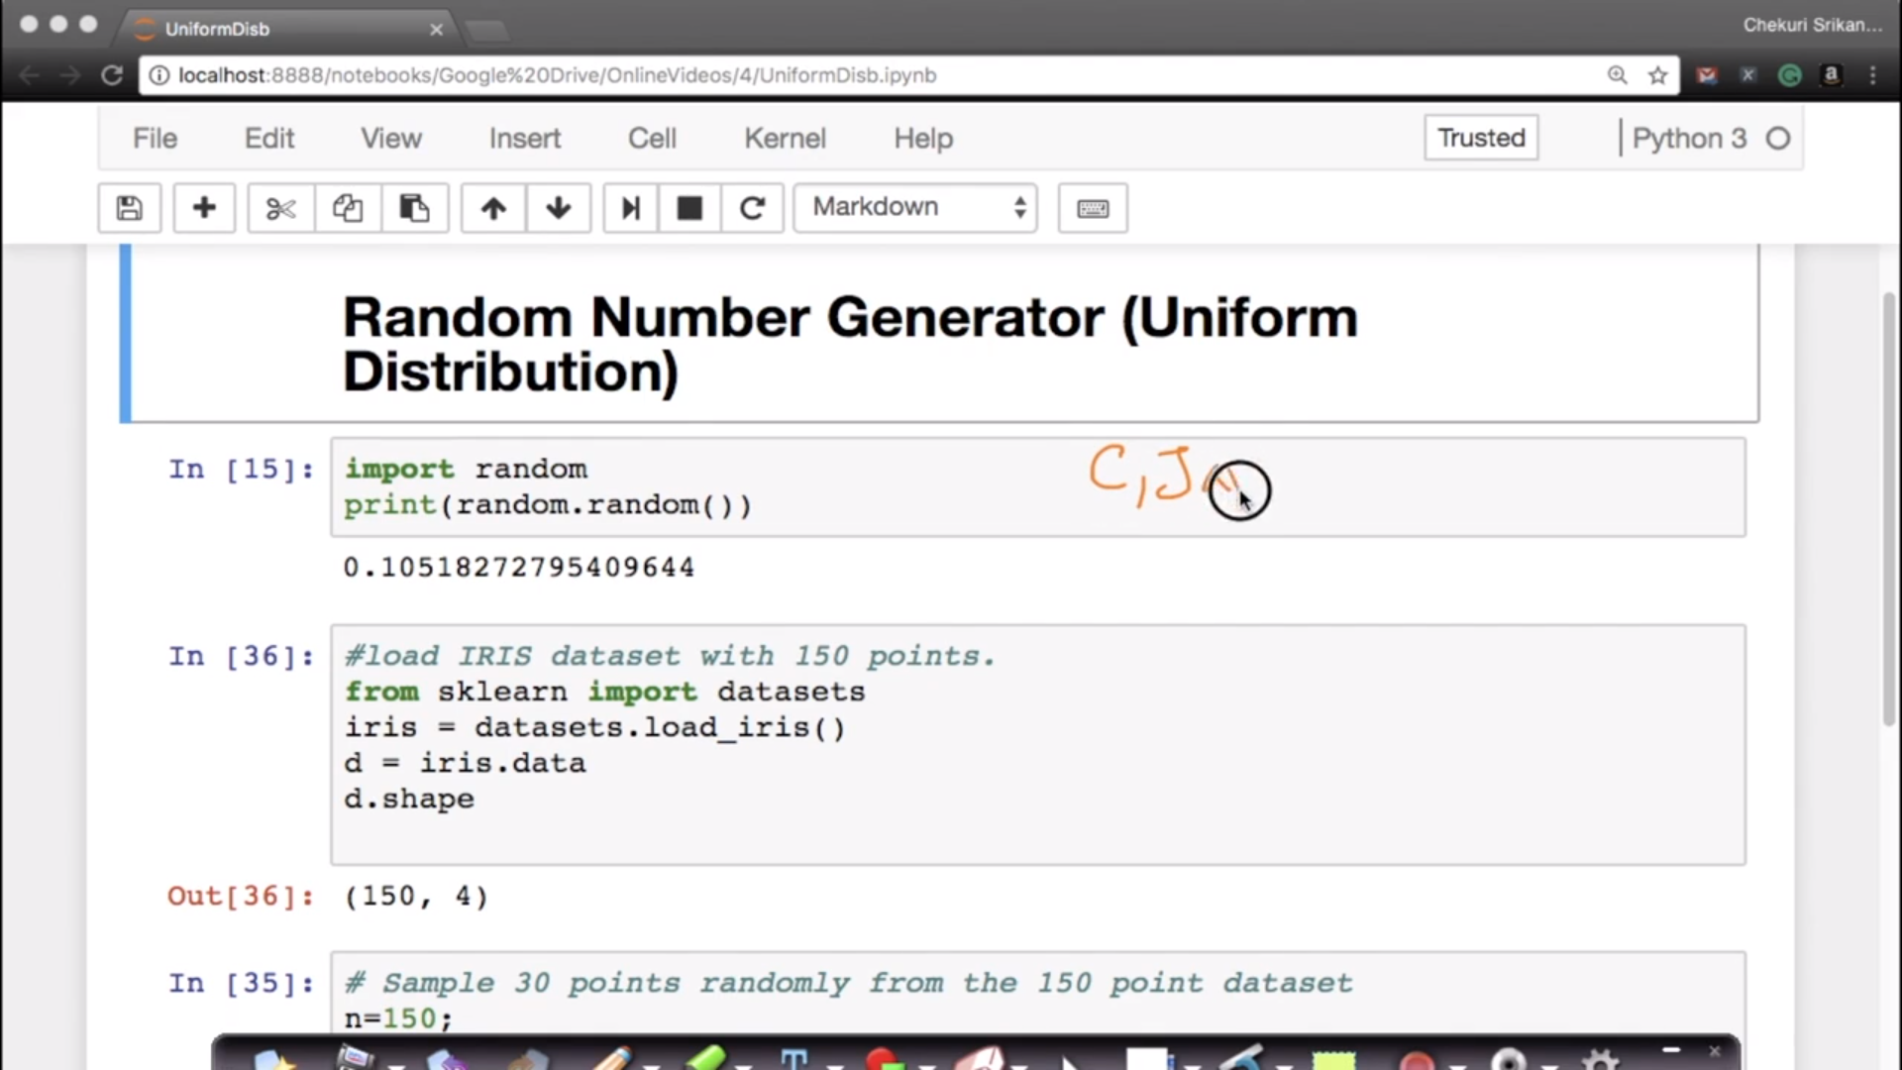

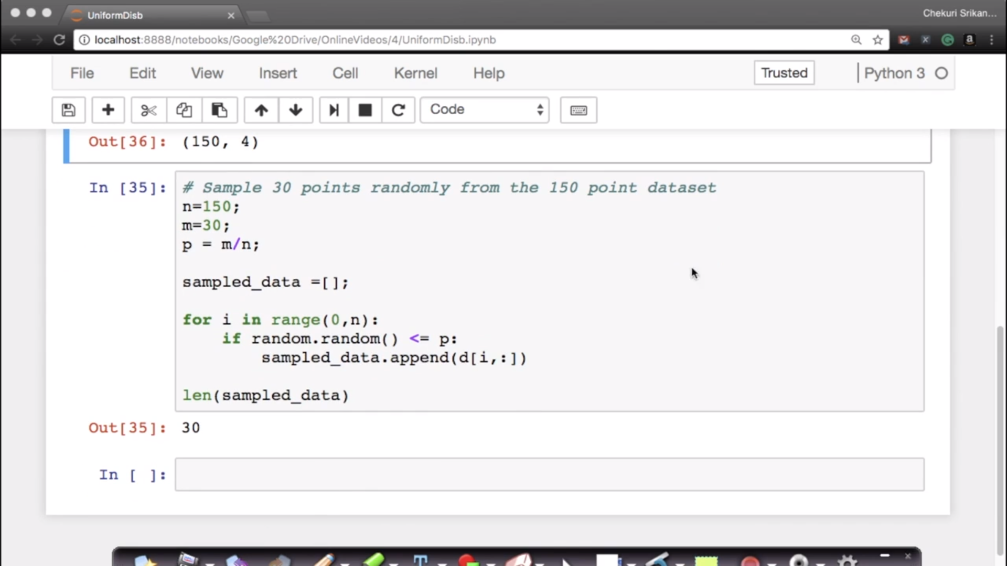

In the below screen it shows len as 30.. we will get approximately 30 .some times we will get 27,28 also.

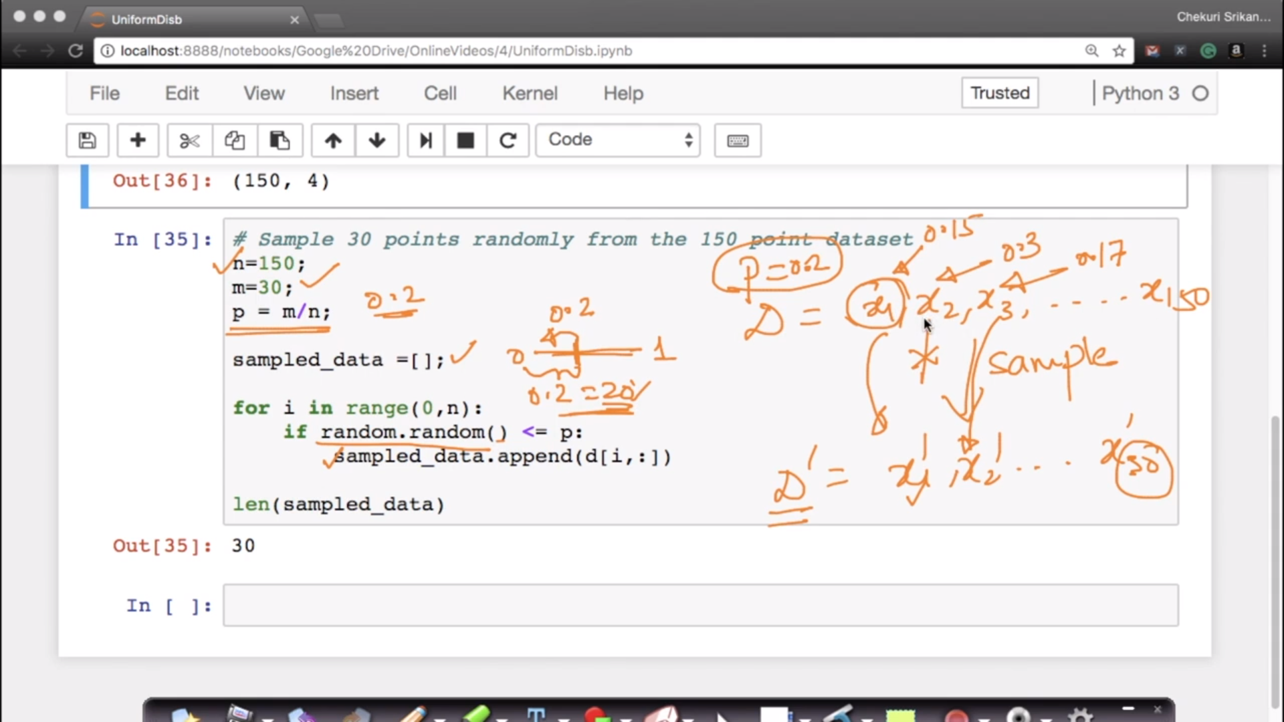

Insread above code we can use like this

Instead of the above code, can we do something like this,  
import numpy as np  
list = []  
for i in np.random.choice(150,30):  
print(d[i])

From comments in applied ai:

Audio explanation: <https://soundcloud.com/user-552490313/randomly-sample-data-points>

🡪

I have 150 datapoints. From 150 data points I need only 30 data points. Which is 20%. How? 30/150 = 0.2 ~ 20% 2) Now what does random.random do? It spits out numbers between [0,1) at random but which is uniformly distributed. 3) Now I am running a for loop that iterates 150 times. Each iteration spits out a number that is between [0,1). 4) Since I am iterating it 150 times. And since I will get a number between [0,1) for each iteration and since it is uniformly distributed, I can say that more or less 30 of my samples will have value =0.2. Now if you do the math it is 20% of your data and 80% of your remaining data. 5) You map this to your IRIS. You get a sample that is uniformly distributed

🡪

if D is 150 and D' is 150, then each point from D has probability of 1(150/150) to be present in D'.  
if D is 150 and D' is 75, only half of the points will make it to D', so for each point the probability will be 50-50 (.5) to make to D'. then each point from D has probability of 1(75/150) to be present in D'.  
if D is 150 and D' is 30, only few of the points will make it to D', so for each point the probability will be < (.5) to make to D'. then each point from D has probability of 1(30/150) to be present in D'.

# **12.14 Bernoulli and Binomial Distribution**

We will have pmf as it is discrete

<https://towardsdatascience.com/understanding-bernoulli-and-binomial-distributions-a1eef4e0da8f>

<https://www.analyticsvidhya.com/blog/2017/09/6-probability-distributions-data-science/>

<https://en.wikipedia.org/wiki/Bernoulli_distribution>

<https://en.wikipedia.org/wiki/Binomial_distribution>

**Bernoulli distribution is the discrete probability distribution of a random variable** which takes the value 1 with probability {\displaystyle p}p and the value 0 with probability {\displaystyle q=1-p}  
{\displaystyle q=1-p}q=1-p

A **Bernoulli distribution** has only two possible outcomes, namely 1 (success) and 0 (failure), and a single trial. So the random variable X which has a Bernoulli distribution can take value 1 with the probability of success, say p, and the value 0 with the probability of failure, say q or 1-p.

Here, the occurrence of a head denotes success, and the occurrence of a tail denotes failure.  
Probability of getting a head = 0.5 = Probability of getting a tail since there are only two possible outcomes.

The probability mass function is given by: px(1-p)1-x  where x € (0, 1).  
It can also be written as

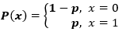

The probabilities of success and failure need not be equally likely, like the result of a fight between me and Undertaker. He is pretty much certain to win. So in this case probability of my success is 0.15 while my failure is 0.85

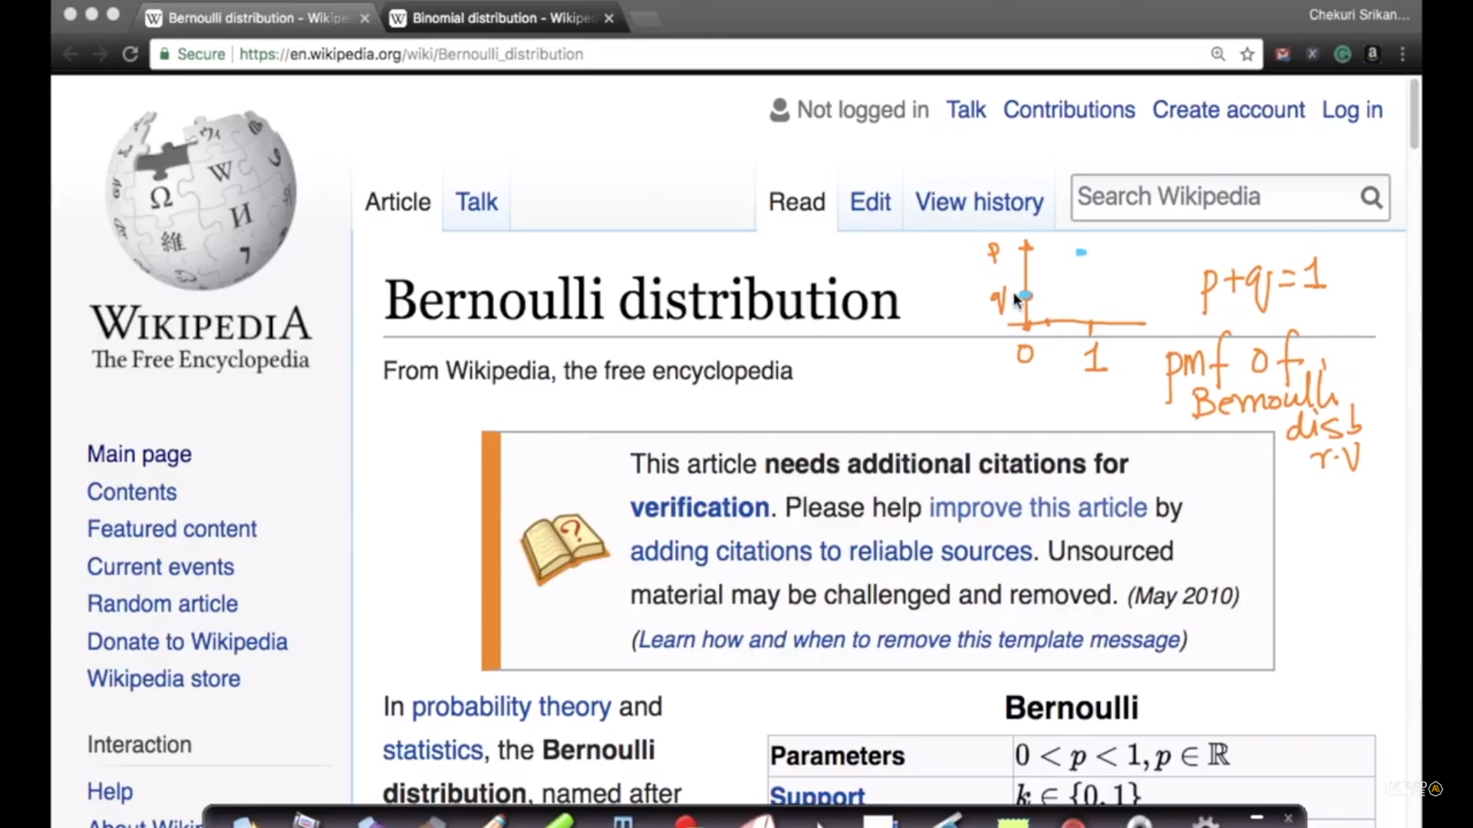

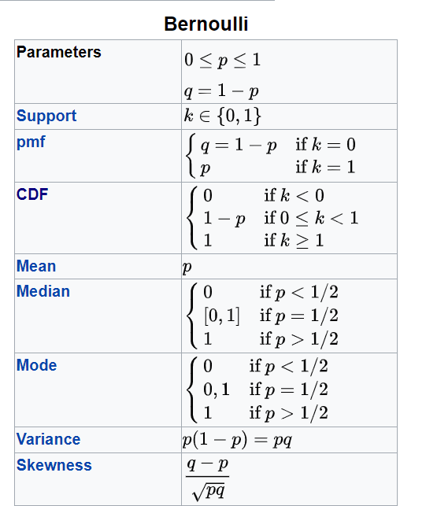

### Binomial Distribution

It is [discrete probability distribution](https://en.wikipedia.org/wiki/Discrete_probability_distribution) , so it will have pmf

 Suppose that you won the toss today and this indicates a successful event. You toss again but you lost this time. If you win a toss today, this does not necessitate that you will win the toss tomorrow. Let’s assign a random variable, say X, to the number of times you won the toss. What can be the possible value of X? It can be any number depending on the number of times you tossed a coin.

There are only two possible outcomes. Head denoting success and tail denoting failure. Therefore, probability of getting a head = 0.5 and the probability of failure can be easily computed as: q = 1- p = 0.5.

A distribution where only two outcomes are possible, such as success or failure, gain or loss, win or lose and where the probability of success and failure is same for all the trials is called a Binomial Distribution.

The outcomes need not be equally likely. Remember the example of a fight between me and Undertaker? So, if the probability of success in an experiment is 0.2 then the probability of failure can be easily computed as q = 1 – 0.2 = 0.8.

Each trial is independent since the outcome of the previous toss doesn’t determine or affect the outcome of the current toss. An experiment with only two possible outcomes repeated n number of times is called binomial. The parameters of a binomial distribution are n and p where n is the total number of trials and p is the probability of success in each trial.

On the basis of the above explanation, the properties of a Binomial Distribution are

1. Each trial is independent.
2. There are only two possible outcomes in a trial- either a success or a failure.
3. A total number of n identical trials are conducted.
4. The probability of success and failure is same for all trials. (Trials are identical.)

The mean and variance of a binomial distribution are given by:

Mean -> µ = n*p

Variance -> Var(X) = n*p*q

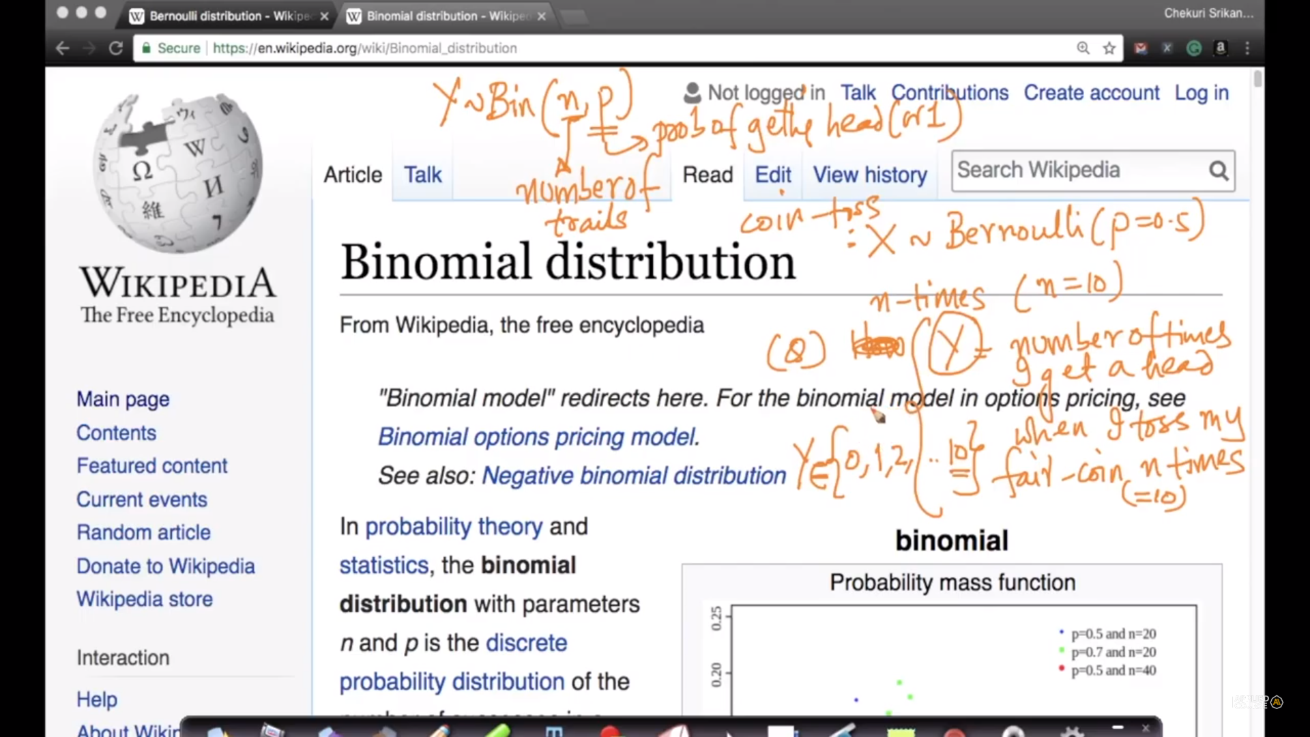

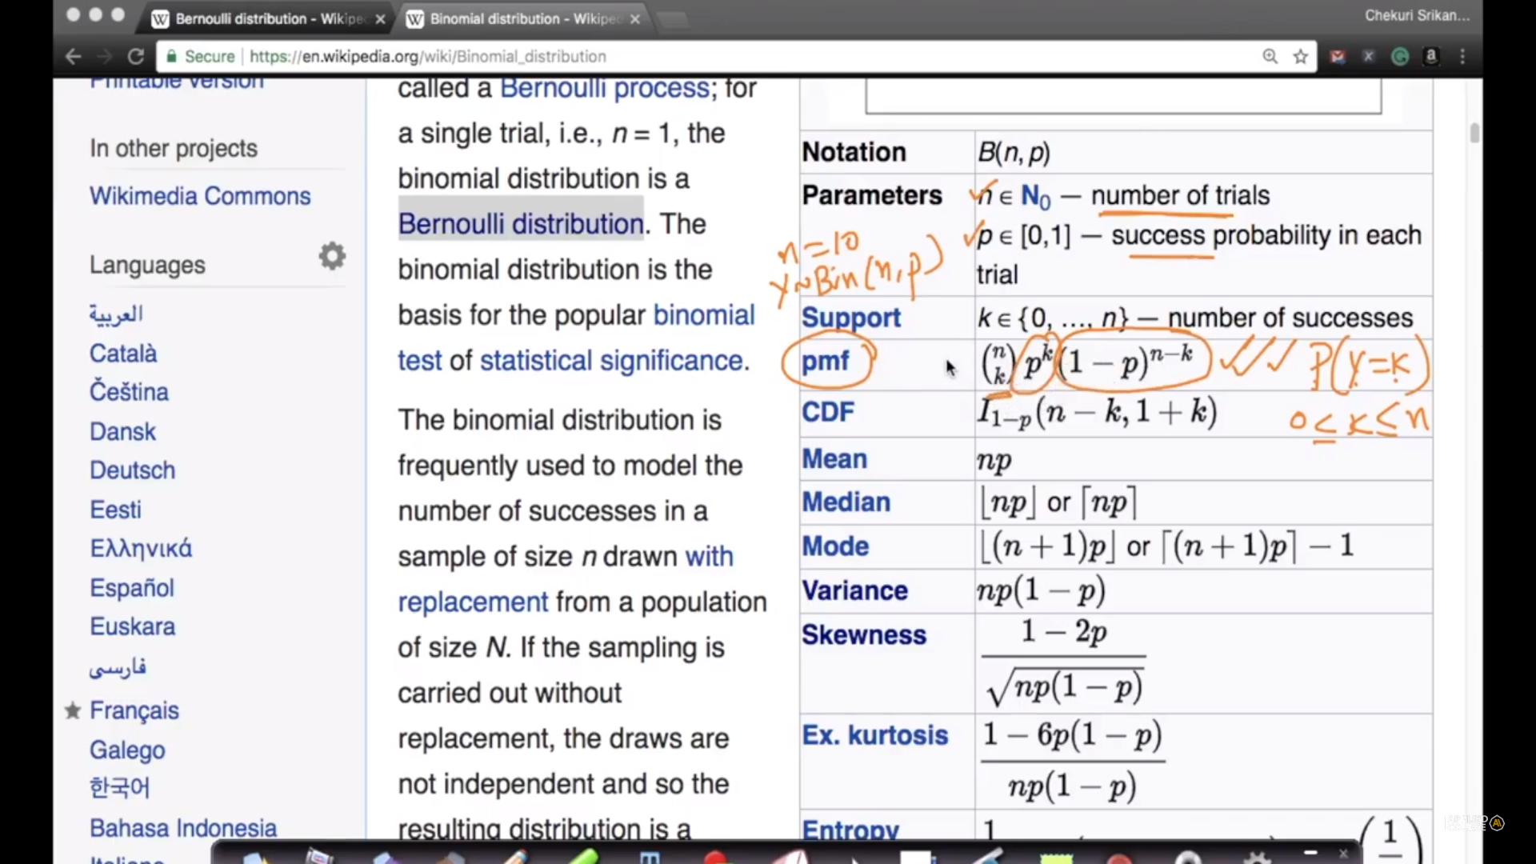

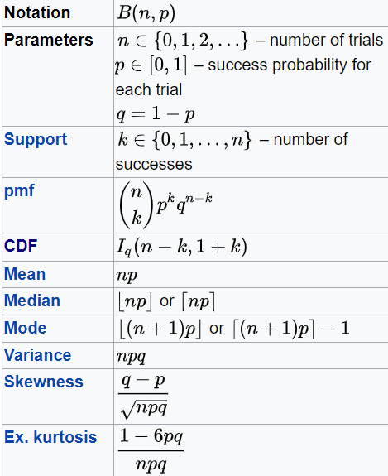

 From comment sections:

<https://math.stackexchange.com/questions/838107/what-is-the-difference-and-relationship-between-the-binomial-and-bernoulli-distr>

<https://towardsdatascience.com/understanding-bernoulli-and-binomial-distributions-a1eef4e0da8f>

pdf n pmf

In probability and statistics, a probability mass function (pmf) is a function that gives the probability that a discrete random variable is exactly equal to some value.[1] The probability mass function is often the primary means of defining a discrete probability distribution, and such functions exist for either scalar or multivariate random variables whose domain is discrete.  
  
A probability mass function differs from a probability density function (pdf) in that the latter is associated with continuous rather than discrete random variables; the values of the probability density function are not probabilities as such: a pdf must be integrated over an interval to yield a probability.  
  
-wiki https://en.wikipedia.org/wiki/Probability_mass_function  
if the value of PDF is 20% for a sepal length 3.5 cm, it implies 20% of flowers has a sepal length of 3.5cm - it should be 20% of the flowers has sepal length less than or equal to 3.5cm  
where if PMF sepal lenth 3.5cm == 0.2 then it means that 20% of the points have sepal length = 3.5cm

probability density function: a function of a continuous random variable, whose integral across an interval gives the probability that the value of the variable lies within the same interval.  
probability mass function: a probability mass function (pmf) is a function that gives the probability that a discrete random variable is exactly equal to some value.

# **12.15 Log Normal Distribution**

<https://www.youtube.com/watch?v=sPzPEeJ4OQ4> -- krishnaik

<https://www.youtube.com/watch?v=kQvYijOikmY&feature=youtu.be> -- appliedai

<https://en.wikipedia.org/wiki/Log-normal_distribution>

X is log normal if natural logarithm of x is normally distributed;

a log-normal (or lognormal) distribution is a continuous probability distribution of a random variable whose logarithm is normally distributed.

Thus, if the random variable X is log-normally distributed, then Y = ln(X) has a normal distribution. Likewise, if Y has a normal distribution, then the exponential function of Y,

X = exp(Y), has a log-normal distribution. A random variable which is log-normally distributed takes only positive real values. It is a convenient and useful model for measurements in exact and engineering sciences as well as medicine, economics and other fields, e.g. for energies, concentrations, lengths, financial returns and other amounts.

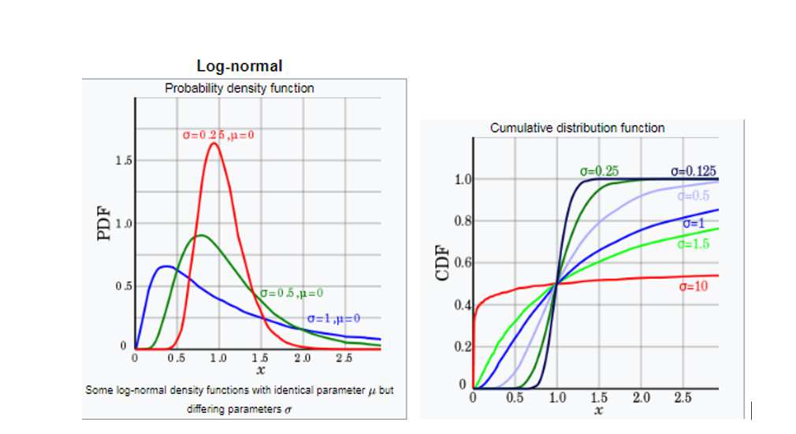

In user reviews: most of comments are of small length and some of comments have large length of words;

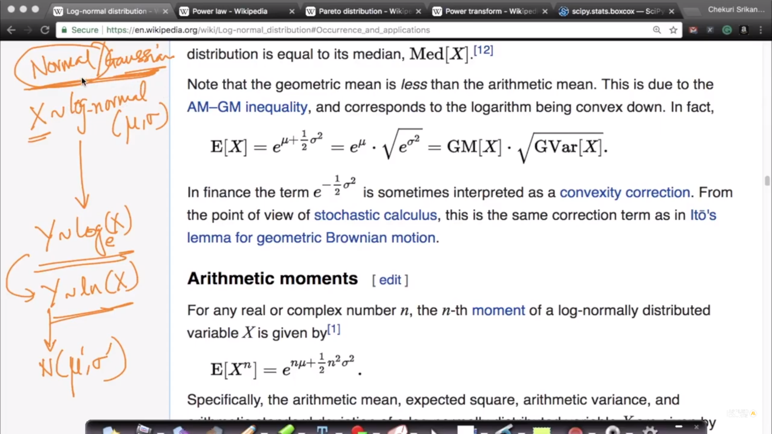

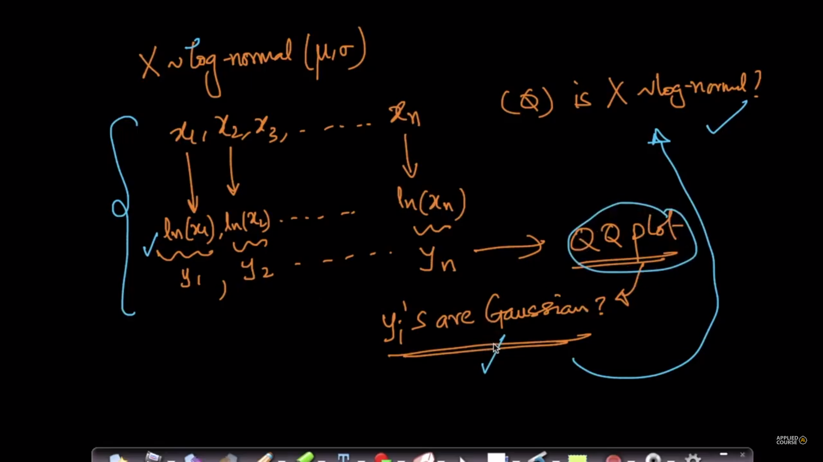

We can employ QQ plot to check similarity of log of distribution to normal distribution;

From comment sections:

🡪

Mostly numpy, scipy for calculations and matplotlib, seaborn for visualization are used.

🡪

even though log normal distribution has skewed curve if we take log of each value in log normal distribution and than plot pdf with this transformed points than it will be bell curve that is normal distribution. and that is the property of log normal distribution. random variable X is called log normal distribution if log(X) is normal distribution

🡪

if a random variable 'X' follows log-normal distribution, then ln(X) will definitely follow normal distribution.

🡪

If you want to check if a given distribution is a Log Normal distribution, then you have to compute the logarithm of all the values given in the distribution and plot them against a randomly generated Normal distribution.  
If you find the plot to be a straight line with most of the points in parallel to the line, then we can conclude that the given data follows log normal distribution.

🡪

Question : How can PDF of a function be greater than 1? The graph from wikipedia shows the PDF of a plot (mean:0, std deviation: 0.25) crossing even 1.5 . Won't this mean that CDF (hence the total probability) will also be greater than 1 which isn't feasible at all?

Answer:

If you recall the Kernel-density estimation, a PDF is computed by adding many gaussian-kernels together. If many points are crowded in a small space, the addition of these kernels will result in a PDF value greater than 1.  
  
Alternatively, we can think of PDF as the derivative of CDF. If a CDF changes sharply indicating that too many data points are converted in a small region, it's derivative in this region will be large making PDF values large.  
  
The most important property of a PDF is NOT the max-value of y-axis but the area under PDF needs to be 1. This can be had if a narrow region in the plot has a y-value > 1 without violating the area constraint.  
  
Detailed explanation: https://www.quora.com/How-does-one-interpret-probability-density-greater-than-one-What-is-the-physical-significance-of-probability-density-Is-it-just-a-mathematical-tool